COURSE OUTLINE – MYP YEAR 3 SCIENCES
At Carson Graham, we strive for excellence in all endeavours, encourage personal and social responsibility, respect diversity and work to develop a life long commitment to learning.
Our aim is to develop inquiring, knowledgeable, confident and caring students who create a better world through intercultural understanding and respect.
UNITS OF STUDY
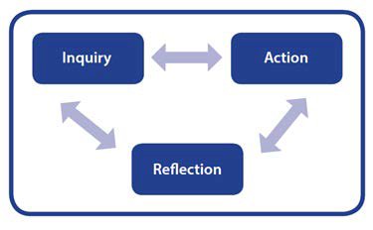
MYP units foster student inquiry and are conceptually based. Concepts have an essential place in the structure of knowledge. They require students to demonstrate levels of thinking that reach beyond facts or topics. Concepts are used to formulate the understanding that students should retain in the future; they become principles and generalizations that students can use to understand the world and to succeed in further study and in life beyond school.
(Developing an MYP Unit, 2014)
Sciences Key Concepts:

- Change
- Relationships
- Systems
Sciences Related Concepts:
- Balance  - Environment  - Function  - Movement | - Consequences  - Evidence  - Interaction  - Patterns | - Energy  - Form  - Models  - Transformation

MYP Global Contexts guide classroom inquiries and encourage an international perspective

- Identities and relationships
- Orientation in space and time
- Personal and cultural expression
- Scientific and technical innovation
- Globalization and sustainability
- Fairness and development

Approaches to Learning
All MYP units of work offer opportunities for students to develop and practice ATL skills. These skills provide valuable support for students working to meet the subject groups aims and objectives.

These skills will be the focus in Sciences:
Category | Skill indicator
Thinking skills | Interpret data gained from scientific investigations
Social skills | Practice giving feedback on the design of experimental methods
Communication skills | Use appropriate visual representations of data based on purpose and audience
Self-management skills | Structure information appropriately in laboratory investigation reports
Research skills | Make connections between scientific research and related moral, ethical, social, economic, political, cultural or environmental factors

The MYP Science course will focus on developing skills related to 4 criteria based objectives.

- Knowing and understanding
- Inquiring and designing
- Processing and evaluating
- Reflecting on the impacts of science

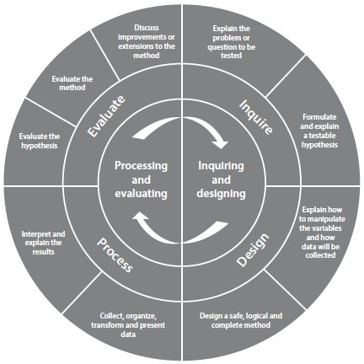
Visualizing the Scientific Process
The scientific process of inquiring, designing, processing and evaluating is represented by MYP sciences objectives B (inquiring and designing) and C (processing and evaluating). The visual representation in figure 4 shows the dynamic relationship between the four areas of experimental design and reporting.

Students will be assessed based on the criteria detailed below and MYP assessment will be both formally (report cards) and informally (feedback on assignments) reported. MYP levels will be used to calculate a student’s overall standing in a course.
Criterion A: Knowing and understanding
Achievement  level | Level descriptor
0 | The student does not reach a standard described by any of the descriptors below.
1-2 | The student is able to:  - recall scientific knowledge  - apply scientific knowledge and understanding to suggest solutions to problems set in familiar situations  - apply information to make judgments.
3-4 | The student is able to:  - state scientific knowledge  - apply scientific knowledge and understanding to solve problems set in familiar situations  - apply information to make scientifically supported judgments.
5-6 | The student is able to:  - outline scientific knowledge  - apply scientific knowledge and understanding to solve problems set in familiar situations and suggest solutions to problems set in unfamiliar situations  - interpret information to make scientifically supported judgments.
7-8 | The student is able to:  - describe scientific knowledge  - apply scientific knowledge and understanding to solve problems set in familiar and unfamiliar situations  - analyse information to make scientifically supported judgments.

Criterion B: Inquiring and designing
Achievement  level | Level descriptor
0 | The student does not reach a standard described by any of the descriptors below.
1-2 | The student is able to:  - state a problem or question to be tested by a scientific investigation, with limited success  - state a testable hypothesis  - state the variables  - design a method, with limited success.
3-4 | The student is able to:  - state a problem or question to be tested by a scientific investigation  - outline a testable hypothesis using scientific reasoning  - outline how to manipulate the variables, and state how relevant data will be collected  - design a safe method in which he or she selects materials and equipment.
5-6 | The student is able to:  - outline a problem or question to be tested by a scientific investigation  - outline and explain a testable hypothesis using scientific reasoning  - outline how to manipulate the variables, and outline how sufficient, relevant data will be collected  - design a complete and safe method in which he or she selects appropriate materials and equipment.
7-8 | The student is able to:  - describe a problem or question to be tested by a scientific investigation  - outline and explain a testable hypothesis using correct scientific reasoning  - describe how to manipulate the variables, and describe how sufficient, relevant data will be collected  - design a logical, complete and safe method in which he or she selects appropriate materials and equipment.

Criterion C: Processing and evaluating
Achievement  level | Level descriptor
0 | The student does not reach a standard described by any of the descriptors below.
1-2 | The student is able to:  - collect and present data in numerical and/or visual forms  - accurately interpret data  - state the validity of a hypothesis with limited reference to a scientific investigation  - state the validity of the method with limited reference to a scientific investigation  - state limited improvements or extensions to the method.
3-4 | The student is able to:  - correctly collect and present data in numerical and/or visual forms  - accurately interpret data and describe results  - state the validity of a hypothesis based on the outcome of a scientific investigation  - state the validity of the method based on the outcome of a scientific investigation  - state improvements or extensions to the method that would benefit the scientific investigation.
5-6 | The student is able to:  - correctly collect, organize and present data in numerical and/or visual forms  - accurately interpret data and describe results using scientific reasoning  - outline the validity of a hypothesis based on the outcome of a scientific investigation  - outline the validity of the method based on the outcome of a scientific investigation  - outline improvements or extensions to the method that would benefit the scientific investigation.
7-8 | The student is able to:  - correctly collect, organize, transform and present data in numerical and/ or visual forms  - accurately interpret data and describe results using correct scientific reasoning  - discuss the validity of a hypothesis based on the outcome of a scientific investigation  - discuss the validity of the method based on the outcome of a scientific investigation  - describe improvements or extensions to the method that would benefit the scientific investigation.

Criterion D: Reflecting on the impacts of science
Achievement  level | Level descriptor
0 | The student does not reach a standard described by any of the descriptors below.
1-2 | The student is able to:  - state the ways in which science is used to address a specific problem or issue  - state the implications of the use of science to solve a specific problem or issue, interacting with a factor  - apply scientific language to communicate understanding but does so with limited success  - document sources, with limited success.
3-4 | The student is able to:  - outline the ways in which science is used to address a specific problem or issue  - outline the implications of using science to solve a specific problem or issue, interacting with a factor  - sometimes apply scientific language to communicate understanding  - sometimes document sources correctly.
5-6 | The student is able to:  - summarize the ways in which science is applied and used to address a specific problem or issue  - describe the implications of using science and its application to solve a specific problem or issue, interacting with a factor  - usually apply scientific language to communicate understanding clearly and precisely  - usually document sources correctly.
7-8 | The student is able to:  - describe the ways in which science is applied and used to address a specific problem or issue  - discuss and analyse the implications of using science and its application to solve a specific problem or issue, interacting with a factor  - consistently apply scientific language to communicate understanding clearly and precisely  - document sources completely.

