Science 8 Name: __________________________
Date: _____________________ Blk: ___

ACTING THE CELL – SUMMATIVE ASSESSMENT

Task: To showcase – through acting and writing - your knowledge of the functions of organelles in a cell.
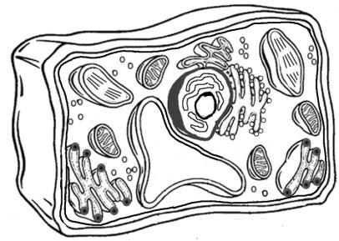

Assessment – Criterion A: Knowing and understanding
- Describe scientific knowledge
- Analyse information to make scientifically supported judgments

Your mission

PART 1: You will be assigned the role of an organelle in a plant cell. You will work with other students in your ‘organelle group’ to understand the function (job) of your organelle, along with where your organelle exists in the cell and what they look like!

The class will then work together to act as one large plant cell, with student acting as organelles – performing and describing their functions and potentially interacting with other organelles. The cell will come alive! Theatre of the Cell!

A variety of appropriate materials will be provided for props. Simple costumes can be used. The performance will be filmed and shown in class!

PART 2: You will answer questions in class about your organelle and others in the cell.

PART 1
Your Role:

Starring (names) ________________, ________________, _________________, and _________________ as (organelle assigned) ______________________

Describe the function of your organelle and name any chemicals it produces or uses:
___________________________________________________________________________________________________________________________________________________________________________________________________________________________________________________________________________________________________________________________________________________________________________________________________________________________________________________________________________________________________________________________________________________________________________________________________________________

