Earth Science 11 Name: _____________________

**Self-Directed Atmosphere and Oceans Unit – Art Project**

Task:

**PART A:** **THE SCIENCE**

1. **Choose at least 2 chapters** you are interested in learning about from the options below.
2. Read the chapters in the Earth Science textbook, and then answer the **assessment questions** at the end of the chapter in your notebook.

**PART B:** **THE ART** (create an **art piece** that displays science you learned.)

1. Choose one science concept to inspire your **ART piece**!
2. **Design and create** your art piece *(diorama, sculpture, painting, paper mache, play, poster, song, model, animation, multimedia installation, etc…)*
3. **Create** a short **written plaque** explaining the science behind your art.

**PART C**: **ART SHOW** - in class on December 17th

OPTIONS: *(Choose* ***at least 2*** *of the following chapters… p.280-454)*

**ATMOSPHERE**

* 11.1 Atmosphere basics
* 11.2 Properties of the Atmosphere
* 11.3 Clouds and Precipitation (rain)
* 12.1 Causes of Weather
* 12.2 Weather Systems
* 12.3 Gathering Weather Data
* 12.4 Weather Analysis and Prediction
* 13.1 Thunderstorms
* 13.2 Severe Weather
* 13.3 Tropical Storms *(hurricanes/cyclones)*
* 13.4 Recurrent Weather *(floods/droughts/cold waves)*
* 14.1 Defining Climate and Causes
* 14.2 Classifying Climates/Microclimates
* 14.3 Climate Changes
* 14.4 Impacts of Human Activities on Climate

**OCEANS**

* 15.1 Overview of Oceans
* 15.2 Seawater
* 15.3 Ocean Movement
* 16.1 Shoreline Features
* 16.2 Seafloor Features

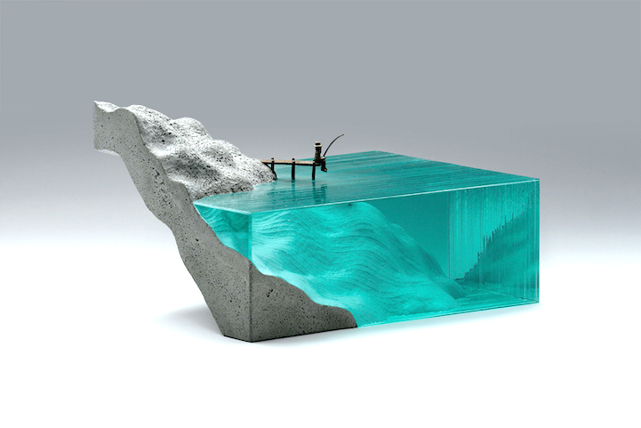

Ben Young - http://brokenliquid.com/

Assessment Criteria

|  |  |  |  |  |
| --- | --- | --- | --- | --- |
| **CRITERIA** | **10-9** | **8-7** | **6-5** | **5-0** |
| **THE SCIENCE** | All questions from 2 or more chapters are answered correctly and completely. | All questions from 2 chapters are answered. | Some questions from 2 or less chapters are answered. | Questions are not answered. |
| **THE ART PLAQUE** | The art plaque contains detailed and correct science! | The art plaque contains science, but may not be detailed or correct. | The art plaque contains minimal science. | Art plaque is not included. |

ART PIECE planning:

**My Art Piece is a ________________________ about ____________________.**

*(Art Type / Media) (Science Topic)*