Earth Science 11 Name:_______________________
Block:___________
The Atmosphere
The Earth’s atmosphere is composed of two main gases, __________________________ and ____________________. In fact, 99% of the atmosphere is made from __________________ and ______________________. The remaining 1% is made from ____________________, _______________________________ and some trace gases. Earth’s atmosphere also contains tiny particles, such as ______________, _____________, and __________.
Note: In the last ________________ years, carbon dioxide has increased from 0.028% to 0.040% concentration in the atmosphere from fossil fuel burning.
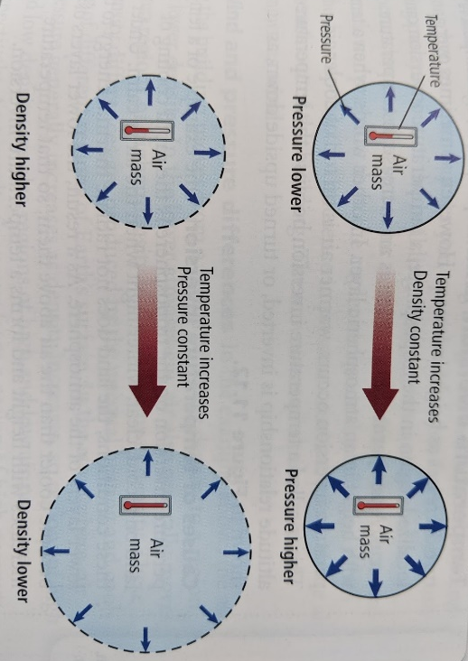
Making Connections: Can you brainstorm some reasons why atmospheric composition might be changing?

Atmosphere has Properties:
If density stay the same; Low temperature = Low pressure and High temperature = high pressure. This is because _______________________ ___________________________.
If Pressure stays the same; Low temperature = High density and High temperature = Low density. This is because _____________________________________________________.
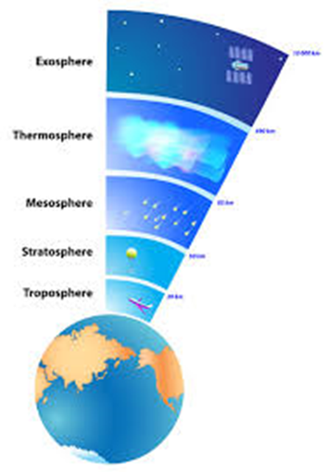
Atmospheric Layers:
Troposphere: The troposphere is the layer of the atmosphere that is the _________________ to the earth’s surface. It is in this layer is where the Earth’s weather occurs and the majority of the Earth’s ____________________ form. Note that as you move higher in the troposphere, the temperature quickly gets much colder, and can get as cold as _____________
Stratosphere: The layer above the tropopause is the stratosphere. The stratosphere is very _ and mostly contains _________________. Ozone is a molecule that absorbs the sun’s energy (preventing harmful rays from reaching the Earth’s surface). Since ozone absorbs the sun’s energy, the stratosphere gets _____________________ than the troposphere.
Mesosphere: This layer is very cold (can get to ________), because very little of the sun’s energy is absorbed.
Thermosphere: The thermosphere is a very hot layer. This layer can get hotter than ___________, because of the low air density and it absorbs a lot of the sun’s energy.
Exosphere: This is the layer between the Earth’s atmosphere and ________________. It is between 500 to 10,000 km above the Earth’s surface.

Weather vs. Climate
- ____________: is the day-to-day state of the atmosphere, and its short-term variations.
  - A combination of temperature, humidity, precipitation, cloudiness, visibility, and wind.
- ____________: is the weather of a place averaged over a period of time (often 30 years)
  - Includes information about normal weather, as well as the range of weather extremes for a location
What are clouds?
- _____________ are ____________ particles that come together around a “condensation nucleus”
- These ____________________________ are particles (such as ________) that were blown up into the atmosphere. If there is enough water in the atmosphere, then the water particles will attach to it, and a cloud will start to form.
- This process is called ______________________
- The droplets that form can be liquid water or ice, depending on the surrounding ___________________
- When the number of these droplets is large enough, a _________________ is visible.
Note: There is constantly water in the Earth’s atmosphere. _________________ is how scientists measure the amount of water in the atmosphere.
Different Types of Clouds
- Different types of clouds form depending on the _________________ and where in the _______________________ the cloud forms.
- There are three main types of clouds: low clouds, medium clouds, and high clouds.
Low Clouds: These clouds form from _____________, moist air. These types of clouds break down into two main categories: cumulus and stratus. ___________________ clouds are puffy and lumpy looking clouds. _____________ clouds look like layers and will cover large parts of the sky. Usually fog is a stratus cloud that drops to the Earth’s surface.
Middle Clouds: These clouds from in the middle of the troposphere, around the point where some of the water particles turn to __________________________. _____________________ clouds are white/grey, large, round masses or wavy rows. ________________ clouds are gray and form thin sheets. Both types of clouds can bring light rain.
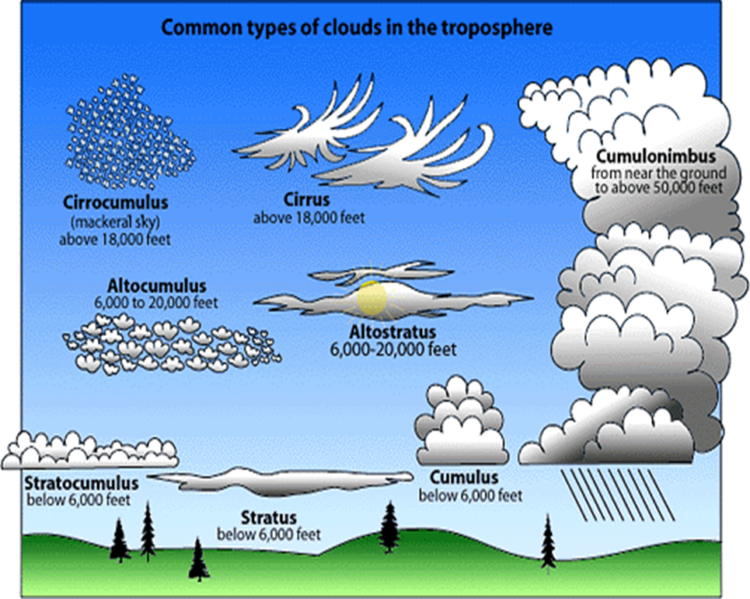
High Clouds: These clouds are made from ____________________ because they form so far above the Earth’s surface. They break down into two main types: cirrus and cirrostratus. __________________ clouds are thin and wispy ________________ clouds act almost like a blanket. They can be very transparent or very dense.
Vertical Cloud Growth: __________________ clouds can grow upwards if the cloud is warmer than the surrounding air. The cloud can grow through middle altitudes as a towering _______________________
If it reaches high enough, the top will be made of ice crystals. Strong winds can spread the top of the cloud into an anvil shape.
These clouds produce torrential rains, strong winds, and hail characteristic of ____________________.

Precipitation
______________________: any liquid water or ice that falls freely from the atmosphere to Earth’s surface.
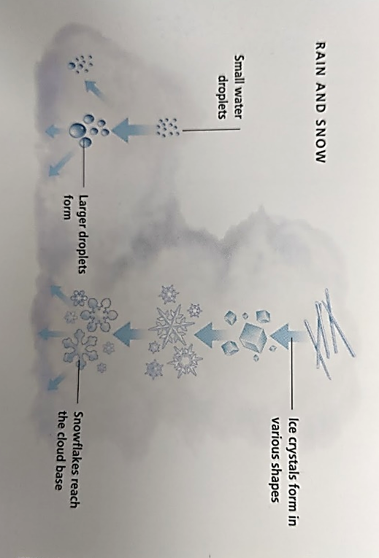
- There are ____________________ of precipitation _______________(rain and drizzle), ______________ (snow, ice, and hail), and ________________ (freezing rain).
______________________: liquid precipitation that falls to the ground from clouds. Rain-producing clouds must be very _______________ to develop large enough raindrops to fall from the cloud.
___________________________: fall when a thick layer of air near Earth’s surface is at or below freezing temperature.
- Snow can fall from ______________ or _______________ clouds
- Hail is a product of _____________________
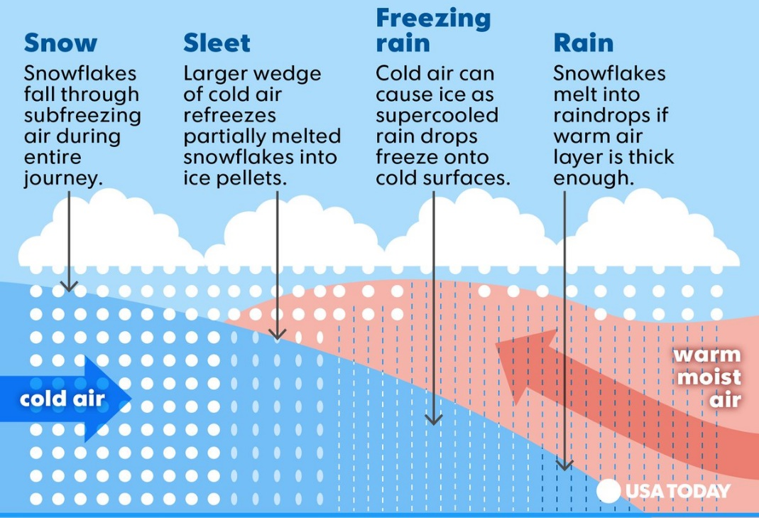
- Ice pellets form when rain falling through a _________ ___________ _________ turns the drops solid

Air Masses
An air mass is a large volume of air that has the ________ characteristics as the __________________________________________ (Such as; ___________________, and ____________). Though each air mass forms at a specific ________________________, they are constantly __________________. There are _________________________ that determine the characteristics of a mass.
- Developed over land: _________________________
- Developed over water: _______________________
- Developed over cold area: ____________________
- Developed over warm area: ___________________
Combine __________ of the categories to determine the _____________________________. There are ___________ types of air masses that affect North America. Each brings it’s own characteristic __________________.
Use the map projected to complete the table below.
Air Mass | Winter Characteristics | Summer Characteristics
Arctic |  | Cold, and dry
Continental Polar | Very cold, and dry | Cool, and dry
Continental Tropical | Warm, and dry
Maritime Polar | Cold to mild, and humid
Maritime Tropical |  | Hot, and humid

Weather Fronts
A front forms when _________________________ with different characteristics ______________. The area at the collision is called a _________________________. Their names are determined by the ________________ air mass. _____________________ occurs along all fronts. There are ____________ different types of fronts: ______________________, ______________________, ________________________, _________________________.
Cold Fronts
When ____________ air moves into and area of ______________ air. Weather caused: ______________________ and ____________________. It’s symbol on a weather map looks like this:
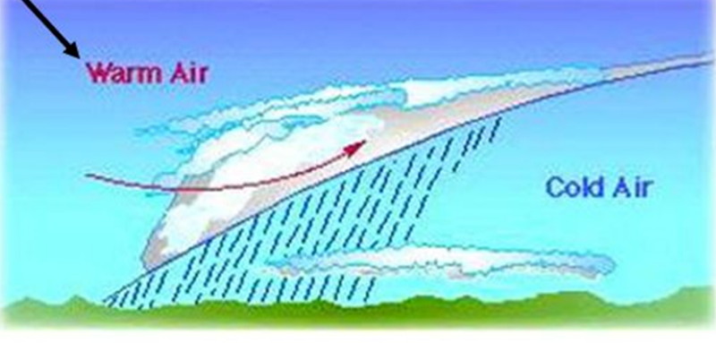
Warm Fronts:
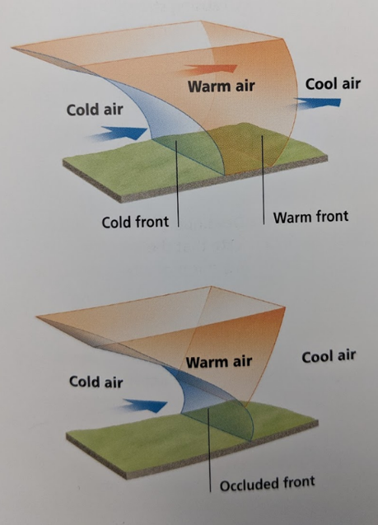
When ____________ air moves into an area of __________________ air. Weather caused: __________, _____________________. It’s symbol on a weather map looks like this:

Occluded Fronts:
When _________________ air mass moves so quickly that it forces ________________ air mass upwards. After one or two days the cold front overtakes the warm front. Weather caused: ________________________ and ____________. It’s symbol on a weather map looks like this:

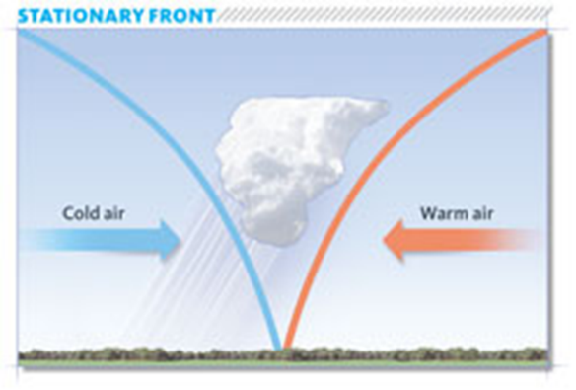
Stationary Fronts:
When two air masses ___________________________. Weather cause: _________________________ (all nice or all bad). It’s symbol on a weather map looks like this:
Pressure Systems
____________________________: zones of high pressure generally occur in __________ air masses, where the air is _____________________. High pressure air masses ___________. Resulting in _____________________ weather.
As the sun heats an air mass, it becomes warmer and ______________________. Since the air mass is now less dense it starts ____________________. This creates a ___________________________ centre. As the air rises, it cools and ___________________ into clouds. Therefore, low pressure centres are associated with ____________________, or ______________________ weather.
Draw arrows on the diagram below showing how air masses are moving
