Earth Science 11 Name: _____________________
Extended Weather Lab Block:________________
Barometer: A barometer measure the atmospheric pressure. Changes in air pressure can forecast short-term changes in the weather. There is no scale for this instrument, discuss with your expert group and mixed group to decide how to record this measurement.
Materials:
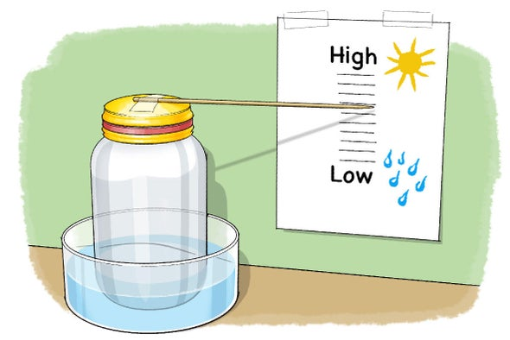
- Glass jar
- Rubber band
- Balloon
- Wooden skewer
- Scissors
- Tape
- Paper
- Pen
- Three bowls – for the whole group
- Tap water (hot and cold)
- Ice cubes

Procedure:
- Gather the necessary materials
- Cut off and discard the opening of the balloon, then stretch the remaining balloon piece around the opening of the glass jar, wrapping it tightly. Secure the balloon with a rubber band.
- Tape the end of the wooden skewer flat onto the top of the balloon.
Testing:
- Fill the first bowl with room temperature water, the second bowl with hot tap water, and the third with ice water.
- Place your barometer close to a wall with the skewer parallel to the wall. Tape a piece of paper behind the barometer on the wall.
- Draw a line on the paper that lines up with the tip of the skewer
- Mark the position where the barometer is placed
- Take the barometer and place it in the bowl with hot water – leave for 1 minute.
- Take it out of the water and quickly place it on the position mark. Make another line on the paper so that it lines up with the skewer.
- Place the barometer in the bowl of room temperature water – leave for 10 minutes.
- Take it out and put it back on the position mark. Make another line on the paper that lines up with the skewer.
- Place the barometer in the bowl of ice water – leave for 1 minute.
- Take it out and put it back on the position mark. Make another line on the paper that lines up with the skewer.
- Repeat steps 10-11.
What do you observe when the water is hot? What about cold? How does the skewer change position?
Are you changing the air pressure of the atmosphere? Or of the jar? Is that important?

To measure at home:
When you seal the glass jar with the balloon, there is a certain air pressure inside the jar. If you measure the atmospheric air pressure, the air outside of the jar pushes on the balloon. With falling atmospheric pressure (ie. Low air pressure) the wooden skewer will point downwards.
- Take your barometer outside to measure atmospheric pressure
- Draw a scale that looks like a ruler on another piece of paper. Place the scale next to the barometer so that the middle line is lining up with the skewer tip.
- Everyday mark where the skewer is pointing.

What type of weather is associated with falling air pressure? Rising air pressure?

