Service Learning Week Name: ________________________________
Date: ____________________ Block: _____

Diversity of Life on Earth through Time

This week, we are discussing diversity within Biology:
- How has biodiversity on Earth changed over time?
- The possible Sixth Extinction.

1. What is the natural background extinction rate?
_____________________________________________________________________________________________

2. What is the difference between extinction and a mass extinction?
__________________________________________________________________________________________________________________________________________________________________________________________________

3. This graph shows the diversity of life (numbers of families) through time (mya).
-Draw lines down to indicate when the five greatest mass extinctions happened.
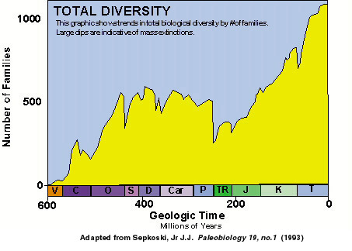

Name (Time Period) | Time (mya) | What went extinct?

b. The Sixth Mass Extinction?

- List the different threats to biodiversity in your group:
_________________________________________________________________________________________

- Debate in your group and choose the most devastation threat to biodiversity. Describe why.

- What can we do as humans to reduce these threats to biodiversity?
___________________________________________________________________________________________________________________________________________________________________________________________________________________________________________________________________________________________________________________________________________________________________________________________________________________________________________________________________________________________________________________________________________________________________________________________________________________________________________________________________________________________________________________________________________________________________________________________________________________________________________________________________________________________________________________________________________________________________________________________________________________

