Name: ________________________ Date: _____________ Blk: ___

Investigating Human and Animal Eyes Assignment

Assignment: You will choose an animal, and create a poster that explains the differences and similarities between the eyes and vision of humans and a specific animal.

I will be comparing the human eye and the _____________________eye (your animal).

On your poster, you need to include the following information:

- How does human vision work?
- What is the anatomy of the human eye? Include diagrams!
- What animal did you choose? Why? How does their vision work?
- What are the similarities and differences between human and animal eyes and your specific animal’s eye?
- How can you display the comparison between the human and animal eyes in an interesting way?
- Big Question: How has the structure of human and animal eyes influenced how each live?

In order for your assignment to be submitted, it must also meet the following criteria before it will be marked:
- Free of spelling and grammar errors; written neatly in blue or black ink or typed.
- Includes a title, name, date, and block.
- Research is organized and clearly presented in an engaging poster format.
- Poster must include labeled colour diagrams of the anatomy of both human and animal eyes.
- All information is written in your own words.

- YOU MUST INCLUDE A LIST OF SOURCES ON THE BACK OF YOUR POSTER.
-APA format, listed alphabetically, neat (we will learn how to do this in the Library)
-NO Wikipedia allowed!!!
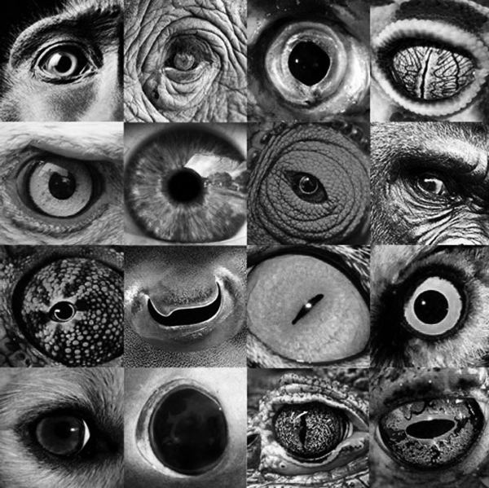

Assessment Criterion

Criterion A: Knowing and understanding
Achievement level | Level descriptor
0 | The student does not reach a standard described by any of the descriptors below.
1-2 | The student is able to:  - recall scientific knowledge  - apply scientific knowledge and understanding to suggest solutions to problems set in familiar situations  - apply information to make judgments.
3-4 | The student is able to:  - state scientific knowledge  - apply scientific knowledge and understanding to solve problems set in familiar situations  - apply information to make scientifically supported judgments.
5-6 | The student is able to:  - outline scientific knowledge  - apply scientific knowledge and understanding to solve problems set in familiar situations and suggest solutions to problems set in unfamiliar situations  - interpret information to make scientifically supported judgments.
7-8 | The student is able to:  - describe scientific knowledge  - apply scientific knowledge and understanding to solve problems set in familiar and unfamiliar situations  - analyse information to make scientifically supported judgments.

Criterion D: Reflecting on the impacts of science
Achievement level | Level descriptor
0 | The student does not reach a standard described by any of the descriptors below.
1-2 | The student is able to:  - document sources, with limited success.
3-4 | The student is able to:  - sometimes document sources correctly.
5-6 | The student is able to:  - usually document sources correctly.
7-8 | The student is able to:  - document sources completely.

Criteria Command Terms
Analyze | Break down in order to bring out the essential elements or structure. To identify parts and relationships, and to interpret information to reach conclusions.
Apply | Use knowledge and understanding in response to a given situation or real circumstances. Use an idea, equation, principle, theory or law in relation to a given problem or issue.
Describe | Give a detailed account or picture of a situation, event, pattern or process.
Interpret | Use knowledge and understanding to recognize trends and draw conclusions from given information.
Outline | Give a brief account.
Recall | Remember or recognize from prior learning experiences.
Solve | Obtain the answer(s) using algebraic and/or numerical and/or graphical methods.
State | Give a specific name, value or other brief answer without explanation or calculation.
Suggest | Propose a solution, hypothesis or other possible answer.

