Geology 12 Name: ________________________
Block: ___________
Resources
- Resources are materials that are necessary for us to live
- Natural Resources: resources that the earth provides
- Renewable Resources: a natural resource that can be replaced by nature in a short time
  - Ex. Water, solar energy, wind energy
- Nonrenewable Resources: a resource that exists in a fixed amounts. They can only be replaced by geological, physical, and chemical processes that take millions of years
  - Ex. Fossil fuels, diamonds, gold, copper
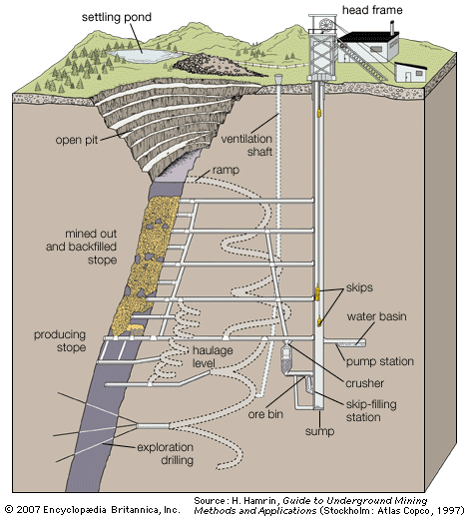
Resources from the crust
- Metals: mined from minerals in the crust
  - Ex. Gold, nickel, copper
- Industrial resources: mined for their commercial value, are not fuel, and are not sources of metals
  - Ex. Gravel, gypsum, talc

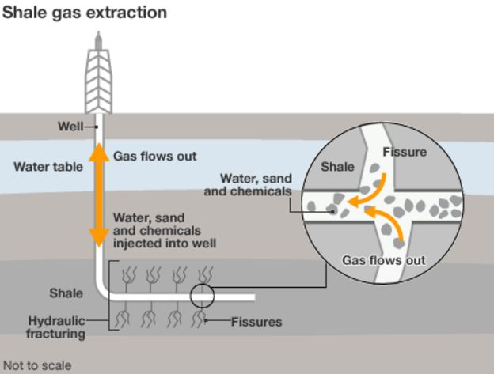
- Fossil Fuels: are hydrocarbons (primarily petroleum, coal, or natural gas) formed from the remains of dead plants and animals.
  - Coal is extracted via mining
  - Petroleum is pumped from underground
  - Natural Gas is pumped or “Fracked”

- Groundwater/Aquifers: groundwater fills the spaces between soil particles and fractured rock beneath the earth’s surface
  - We extract groundwater with wells
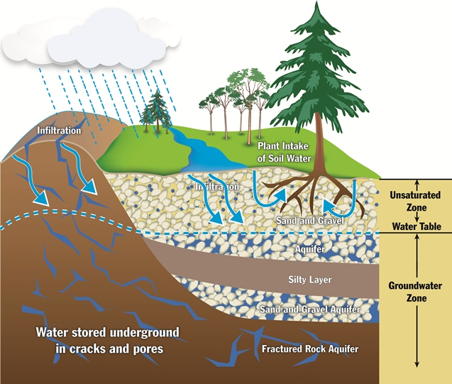

Mining in Canada
- Mineral Production: Canada is the leading producer of ______________, 2nd largest producer of __________________, and 3rd largest producer of ______________________________
- Canada is a key global producer of ____________, ____________ and ___________, and _______________________________________
  - These commodities are crucial in the production of solar cells, high-density batteries and wind turbines.
- ______________________: the search for materials in the Earth’s crust, where concentration and quantity allow for extraction and processing at a profit.
  - Over ___________________ is spent annually on mineral exploration in Canada
- In 2017, the mining sector contributed ___________________ to Canada’s GDP (________).
- ____________: The minerals sector employs over _______________people directly, and indirectly
- Canada trades mineral imports and exports including ores, concentrates, and mineral products in excess of ____________________annually.
- Mineral exports account for nearly _______________of Canada’s total exports
Life of a mine
- Stage 1: ____________________, this can last anywhere from a few years, to a few decades
- Stage 2: ___________________, at this stage, geologists have determined that there is enough “ore” to merit a profitable mine
- Stage 3: ____________________
  - Permits for expanding exploration to determine the size and shape of the mine
  - Environmental impact assessments
- Stage 4: _____________________, companies must not only finance the construction of the mine, but also the future remediation of the mine site
- Stage 5: ___________________
- Stage 6: ________________
- Stage 7: ____________________

