Miley Cyrus spent weekend in Great Bear Rainforest in bid to save our wolves

BY BETHANY LINDSAY, VANCOUVER SUN SEPTEMBER 21, 2015

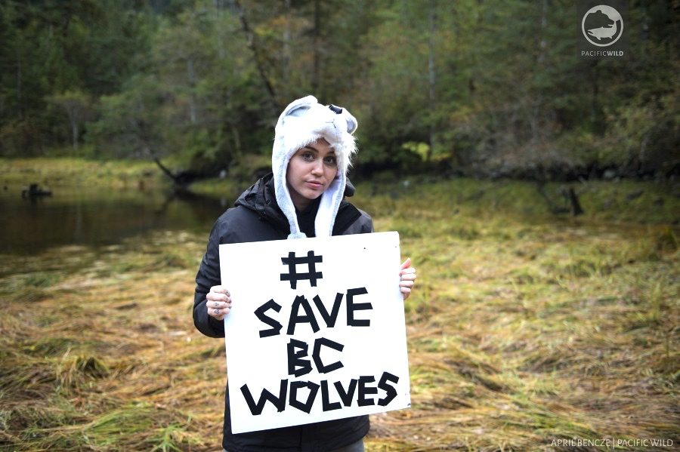

Miley Cyrus is on a mission to save B.C.'s wolves. She is photographed here at the Great Bear Rainforest on the central coast.
Photograph by: Pacific Wild.

VANCOUVER - Pop star Miley Cyrus paid a visit to the Great Bear Rainforest this weekend to learn more about the local wolf cull and trophy hunting.

The former child actor travelled to Klemtu this weekend after contacting the local conservation group Pacific Wild. She was accompanied by members of the Kitasoo/Xais’Xai First Nation, wolf biologists Mary and John Theberge and ecologist Carl Safina.

“When I first spoke out, I knew in my heart that the wolf cull was wrong,” Cyrus said in a news release from Pacific Wild.

“But after this visit, I know science is on my side, not just on the wolf cull, but also on the trophy hunt issue. Both are unsustainable and both are horrific. Both have to end.”

Earlier this month, when she asked her fans to sign a petition against the cull, Cyrus earned the ridicule of Premier Christy Clark, who deadpanned that the singer should stick to twerking.

Clark maintained that Cyrus doesn't know anything about the reasons behind the cull, which the province says is necessary to protect endangered caribou. Sharpshooters in helicopters killed 84 wolves in B.C.’s northeast and southeast regions last winter.

In a video from her trip, Cyrus acknowledged that her music career is “really unimportant” compared to the work of the biologists she met this weekend.
“But if I didn’t do those things, then I wouldn’t have the voice I have to be the megaphone for what these amazing people have researched for so long and can teach me,” she said.

The video shows Cyrus marveling over her close encounters with wolves, bears, whales — and even salmon. At one point, she says she’s seen 10 bears in a single day: “This is a good day.”

The premier also lashed out recently at local actress Pamela Anderson, who published an open letter to Clark condemning the cull. Clark used the challenge as a chance to mock the former Baywatch star and Cyrus for their sometimes skimpy clothing choices.

The province started its controversial wolf cull on Jan. 15, 2015, the first year of a five-year plan to cull the wolves, which were shot from helicopters.

"Habitat recovery continues to be an important part of caribou recovery, but cannot address the critical needs of these herds in the short term," said the government in a statement.

A number of mountain caribou herds are on the brink of local extinction in parts of B.C.

The mounting opposition to the cull comes as the province says it plans to increase the number of wolves killed this winter. Low snowpack and bad weather made the hunt difficult last time around, and hunters were unable to reach their target number of close to 200 kills.

With files from The Canadian Press
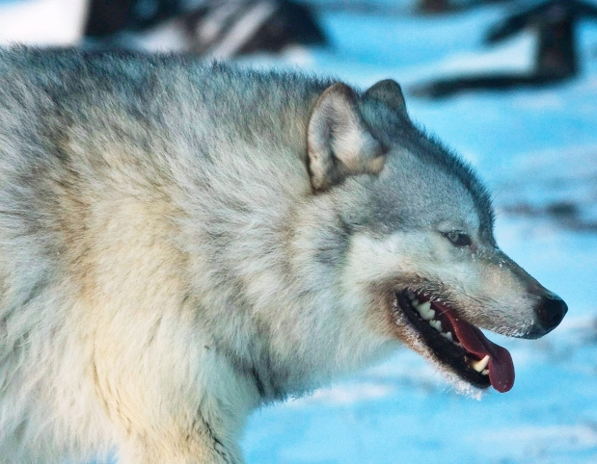
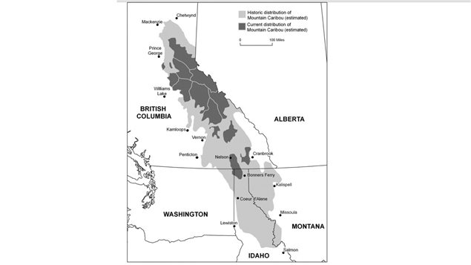

The province says 84 wolves were 'removed' as part of its wolf cull project.

(Nathan Denette/Canadian Press)

Science 10 Name: ________________________
Date: _________________ Blk: ___

Should the BC government continue or stop the wolf cull? Discuss and evaluate the scientific implications of your decision.

______________________________________________________________________________________________________________________________________________________________________________________________________________________________________________________________________________________________________________________________________________________________________________________________________________________________________________________________________________________________________________________________________________________________________________________________________________________________________________________________________________________________________________________________________________________________________________________________________________________________________________________________________________________________________________________________________________________________________________________________________________________________________________________________________________________________________________________________________________________________________________________________________________________________________________________________________________________________________________________________________________________________________________________________________________________________________________________________________________________________________________________________________________________________________________________________________________________________________________________________________________________________________________________________________________________________________________________________________________________________________________________________________________________________________________________________________________________________________________________________________________________________________________________________________________________________________________________________________________________________________________________________________________________________________________________________________________________________________________________________________________________________________________________________________________________________________________________________________________________________________________________________________________________________________________________________________________________________________________________________________________________________________________________________________________________________________________________________________________________________________________________________________________________________________________________________________________________________________________________________________________________________________________________________________________________________________________________________________________________________________________________________________________________________________________________________________________________________________________________________________________________________________________________________________________________________________________________________________________________________________________________________________________________________________________________________________________________________________________________________________________________________________________________________________________________________________________________________________________________________________________________________________________________________________________________________________________________________________________________________________________________________________________________________________________________________________________________________________________________________________________________________________________________________________________________________________________________________________________________________________________________________________________________________________________________________________________________________________________________________________________________________________________________________________________________________________________________________________________________________________________________________________________________________________________________________________________________________________________________________________________________________________________________________________

Criterion D: Reflecting on the impact of Science (Year 5) Name: __________________________ IB Mark: /8

8-7 | 6-5 | 4-3 | 2-1 | 0 | S | T | Comment
discuss and evaluate the implications of using science and its application to solve a specific problem or issue, interacting with a factor | discuss the implications of using science and its application to solve a specific problem or issue, interacting with a factor | describe the implications of using science and its application to solve a specific problem or issue, interacting with a factor | outline the implications of using science to solve a specific problem or issue, interacting with a factor | Not met any of the descriptors listed |  |  | Implications of factor on problem

Explain: Give a detailed account, with scientific reasoning and connections between situations, events, patterns and processes
Describe: Give a detailed account or picture of a situation, event, pattern or process
Outline: Give a brief account
Discuss: Offer a considered and balanced review that includes a range of arguments, factors or hypotheses. Opinions or conclusions should be presented clearly and supported by appropriate evidence
Evaluate: Make an appraisal by weighing the strengths and limitations
Summarize: Abstract a general theme or major point(s)
Factors: social, economic, political, environmental, ethical, moral

