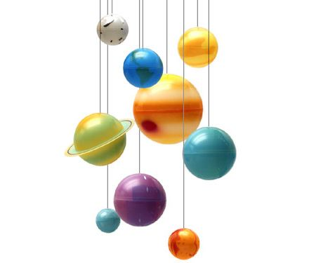Earth Science 11 - Astronomy Name: _______________________

Date: _________________ Blk: ___

**MODEL THE UNIVERSE PROJECT**

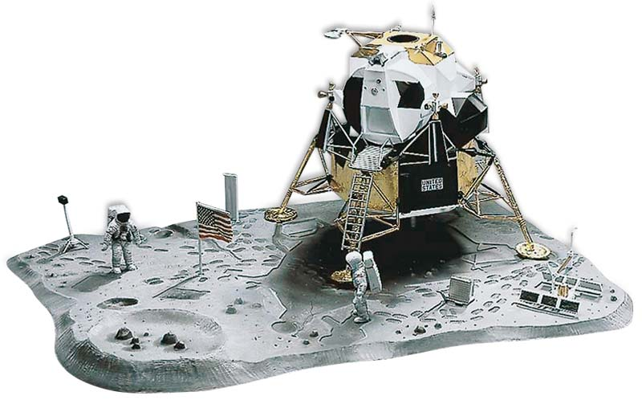**Task**: to build a scale model to investigate a driving question in Astronomy. Your model must be designed to teach, as they will be displayed to my Grade 8 Science classes.

* This is an **individual** investigation.

**Steps:**

**1. Choose a Subject.**

* 1. Choose a subject in Astronomy that **interests** you:

***Exploring the Solar System***

* *The Sun*

Formation, Structure, Flares, Sunspots

* *The Moon*

Formation, Structure, Surface, Tides

* *Lagrange Points*
* *Other Planet-Moons System*

eg. Mars-Phobos-Deimos

* *The Solar System*

**Planets**: Mercury, Venus, Mars, Jupiter, Saturn, Uranus, Neptune

**Dwarf Planets**: Pluto, Ceres, Eris…

**Moons:** Europa, Io, Enceladus, Titan…

* *The Asteroid Belt*
* *Kuiper Belt*
* *Oort Cloud*
* *Comets / Meteors / Asteroids*
* *Should we invest in planetary protection from impacts?*
* *Where should we colonize?*
* *How do astronauts survive long deep space voyages?*

***Exploring the Universe***

* *Types of Stars (Giants/Dwarfs)*
* *Constellations*
* *Exoplanets (Super-Earths?)*
* *Supernovas vs Hypernovas*
* *Types of Galaxies*
* *Nebulae*
* *Black Holes*
* *Quasars / Pulsars*
* *Worm Holes*
* *Dark Matter / Dark Energy*
* *The Big Bang Theory*
* *The Expanding Universe*
* *Heat Death of the Universe*
* *Big Crunch vs Big Rip*
* *The Multiverse Hypothesis*
* *Time Dilation*
* *What is Gravity?*
* *Are we alone in the Universe?*
* *Drake Equation*
* *Fermi Paradox*
* *Can we go faster the light speed?*
* *What was before the Big Bang?*
* *What is beyond the Universe?*
* *What is nothing?*

***Human Space Exploration***

* *Telescopes:*

Hubble, James Webb, Spitzer, Kepler, Chandra, Herschel, Arecibo, VLA…

* *Human Spacecraft:*

Rockets, Space Shuttle, International Space Station (ISS), Soyuz, Space Launch System (SLS), Orion, Dragon…

* *Satellites and Probes*

Sputnik, Voyager, Cassini*,* New Horizons, Rosetta, Juno…

* *Moon Landing*

Apollo 11, Luna, Chang’e…

* *Mars Rovers*

Spirit, Opportunity, Curiosity…

* *Space Exploration Disasters:*

Apollo 1, Apollo 13, SS Challenger, SS Columbia…

*Private Spacecraft:*

SpaceX, Virgin Galactic, Blue Origin, Orbital Sciences Corp

* *Future Technologies*

Space Elevator, Asteroid Mining, Solar Sails, Robots, FTL drives,

* *Should we invest in space exploration?*

**2. Ask a Driving Question that will direct your research:**

* Explain **why** you chose this question:
* Have the Driving Question **approved** by Mr. Bond: Teacher Initials: ____

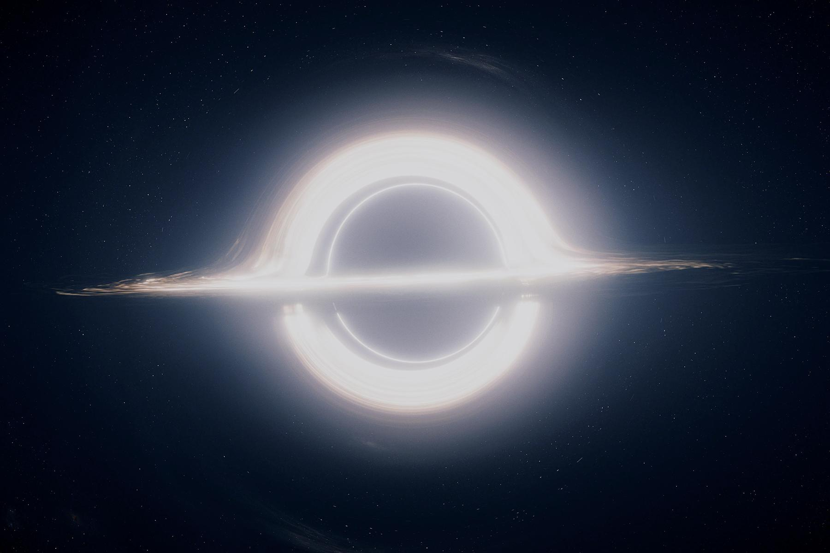**3. Research your Subject and answer your Driving Question:**

* 1. Record your findings using APA format in a Reference list.

**4. Design and Build a Model explaining your question:**

* 1. You will not get much time in class to create your models.
  2. Schedule time with your group members to work **outside** of school time.
  3. You are required to **write a description of the model**, describing your subject and answering your Driving Question. A museum plaque or information card…
  4. 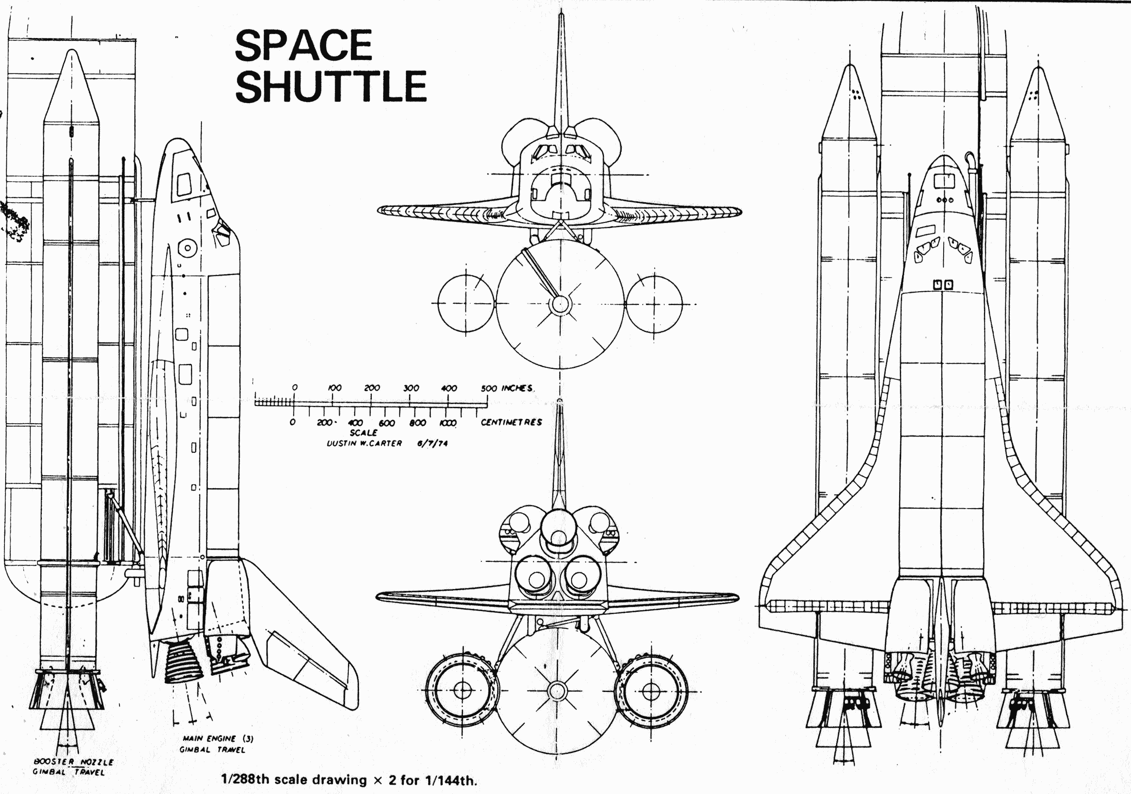Attach the explanation to the model, easily accessible read.

PROJECT IS DUE on: **June 6th**

**Model the Universe Project Grading Rubric**

*Performance Indicators*

|  |  |  |  |  |
| --- | --- | --- | --- | --- |
| **CRITERIA** | **Gold (5 points)** | **Silver (4)** | **Bronze (3-2)** | **No Medal (1-0)** |
| *Research:*  ***Question*** | A Driving Question **showing** **personal interest** is included, with a **clear explanation** of why you chose it. | A Driving Question is included, with an **explanation** of why you chose it. | A Driving Question is included, **without an explanation**. | A Driving Question is **not** included. |
| *Research:*  ***References*** | A **range** of references (5 or more) are included and formatted in **APA style correctly**. | References (at least 3) are included and formatted in **APA style**. | References (at least 3) are included as **links**. | References are **not** included. |
| *Model:*  ***Accuracy*** | Model is **scientifically accurate**, as it represents real life!  **All** dimensions of the model are to **scale.** | Model is **mostly** scientifically accurate.  **Most** dimensions are to scale. | Model is **somewhat** accurate.  Scale was attempted. | Model is **not** accurate.  Scale was **not** attempted. |
| *Model:*  ***Quality*** | Model is well built, **effort is apparent.** Wow! Added detail shows **deeper understanding!** | The quality of the Model is **adequate**, but lacks polish.  Effort is **apparent**. | The quality of the Model is **poor**.  **Some** effort is apparent. | Effort is **not** apparent. |
| *Model:*  ***Explanation*** | Reader receives **complete knowledge** through reading the material! | Explanation is **good**. Shows solid understanding of topic. | Explanation is **basic**.  Information is missing. | Explanation is **not included.** |
| **TOTAL** | **/ 25** | | | |