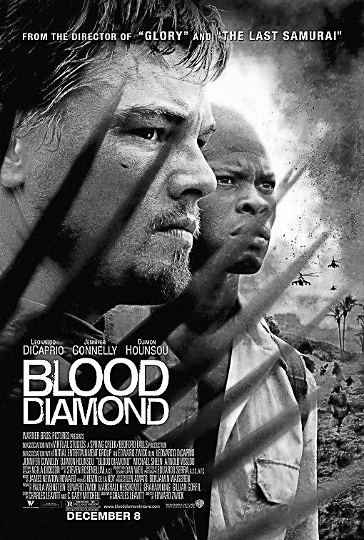
Earth Science 11 Name: __________________________
Date: ___________________ Bk: ____
Science in Movies – BLOOD DIAMOND
Throughout our Earth Science course, we will be watching and analysing several science-based films.
Our task is to determine how well the science is represented. Complete this worksheet over two classes.
Good science vs Bad science!

- Fill in the following Character Descriptions chart:

Character Name | Actor | Job | What do they want?
__________ Archer | Leonardo DiCaprio
__________ Vandy | Djimon Hounsou
__________ Bowen | Jennifer Connolly
Colonel __________ | Arnold Vosloo

- Define “blood diamond.”
____________________________________________________________________________________________________________________________________________________________________________________________________________________________________

- Describe in detail the situation in Sierra Leone shown in the movie
______________________________________________________________________________________________________________________________________________________________________________________________________________________________________________________________________________________________________________________________________________________
- Why are diamonds valuable?

____________________________________________________________________________________________________________________________________________________________________________________________________________________________________________________________________________________________________________________________________________________________________________________________________________________________________________________________________________________________________________________________________________________________________________________________________________________________________________________________________________________________________________

- Should we ban the purchase of diamonds worldwide?

_____________________________________________________________________________________________________________________________________________________________________________________________________________________________________________________________________________________________________________________________________________________________________________________________________________________________________________________________________________________________________________________________________________________________________________________________________________________________________________________________________________________________________________________________________________________________________________________________________________________________________________________________________________________________________________________________________________________________________________________________________________________________________________________________________________________________________________________________________________________________________________________________________________________________________________________________________________________________________________________________________________________________________________________________________________________

