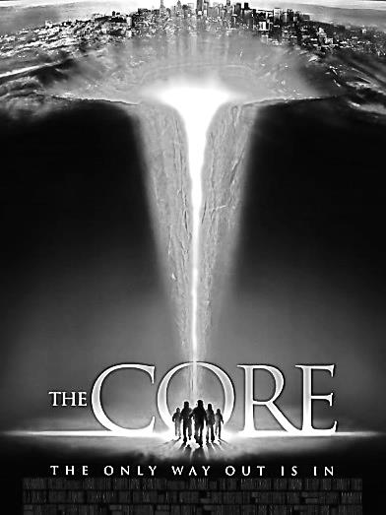
Earth Science 11 Name: __________________________
Date: ___________________ Bk: ____
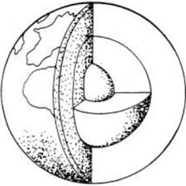
Science in Movies – THE CORE

Throughout our Earth Science course, we will be watching and analysing several science-based films.
Our task is to determine how well the science is represented. Complete this worksheet over two classes.
Good science vs Bad science!

- Fill in the following Character Descriptions chart:

Character Name | Actor | Job | What do they want? | How do they die?
Dr. ________ Keys | Aaron Eckhart
Maj. Rebecca _________ | Hilary Swank
Dr. Conrad _________ | Stanly Tucci
Dr. Ed “Braz” _____________ | Delroy Lindo

- What is the name of the drilling ship? ____________________

- Where on Earth does the ship enter the crust? _________________ Why is this a good place to drill through the crust?
____________________________________________________________________________________________________________________________________________________________________________________________________________________________________

4. Explain how the Outer Core stopped rotating in the film. What effects did this have on the planet?

____________________________________________________________________________________________________________________________________________________________________________________________________________________________________
5. In as much detail as possible, describe what was their plan was to restart the Outer Core. ______________________________________________________________________________________________________________________________________________________________________________________________________________________________________________________________________________________________________________________________________________________

6. Analyse the science in the film. What is some bad science and what is some good science?
BAD SCIENCE in The Core
GOOD SCIENCE in The Core

7. Describe the layers of the Earth. Include the names, what they are made of, and what state they are in (solid/liquid/gas).
__________________________________________________________________________________________________________________________________________________________________________________________________________________________________________________________________________________________________________________________________________________________________________________________________________________________________________________________________________________________________________________________________________________________________________________________

