Geology 12 Names: ______________________________________

Design your own Palaeo Crime Scene

Big Idea: Incomplete geological fossil evidence can be used to recreate the past.
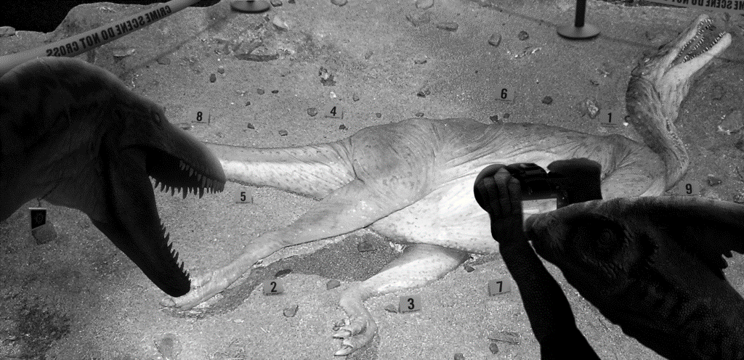
Task: You are to design your own Palaeo Crime Scene!

Advice: Model your project after the Cretaceous
Crime Scene activity we experienced in class:

- Choose a victim and a murderer
- Determine the location of the crime (time and place)
  - Consider the geologic time period, as well as how many years ago.
  - Consider the country and what the continent looked like in the past.
- Decide on the crime
  - Include a diagram of the crime scene (the fossil site)
- Consider what evidence might be preserved
  - Fossils, plant and animals, bones, shells, teeth,
    - articulated vs disarticulated vs isolated fossils
    - Any damage – bite marks, claw marks, wear?
  - Trace fossils, tracks, patterns and trackways
  - Rock types and sedimentary structures - indicating types of environment
- Possible Suspects
  - Motives! – why did they do it?
  - Their “weapons” – how could they have committed the crime?
  - When and where they lived
- An answer key
  - Explain your answer – the reconstructed story of the crime!
  - Other…

Your PalaeoCrime can occur in any time period in the Geologic Time Scale, except the Precambrian and Holocene.

Product: You can choose any display option: power point or google-slides, case file, film, documentary, kit, etc…

Ok by teacher:____________

If you are having trouble creating your own crime scenario, you could instead choose from one of the following famous real-world palaeontology sites:

- BC’s Burgess Shale Fossils
- North American Western Interior Seaway
- Nova Scotia Joggins Cliff (Hylonomus)
- Alberta Centrosaurus bonebeds
- Sue the Tyrannosaurus
- Lyme Regis, UK - Mary Anning fossils
- Australian Ediacara Fossils
- Giant insects of the Carboniferous
- Dunkeosteous of Devonian
- Dimetrodon of the Permian
- Sea Scorpions of the Silurian
- Ghost Ranch, Triassic (Coelophysis)
- Solnhofen, Germany (Archaeopteryx)
- China Lagerstagten (Feathered Dinosaurs)
- BC’s huge Shonisaurus
- Flaming Cliffs (Velociraptor/ Protoceratops)
- La Brea Tar Pit, LA, USA
- Terror Birds of the Paleocene/Eocene
- Ice Age (Mammoth, Smilodon)
- Como Bluff, Wyoming, Jurassic
- Peace River, BC Dinosaur Footprints
- Neanderthal Caves, France
- Valley of the Moon, Argentina (Eoraptor)
- Olduvai Gorge, Tanzania
- Dinosaurs of Madagascar, Africa
- Basilisaurus of Egypt
- Mammoths of Floriensis Island
- South American Mammals of the Pleistocene
- Moa of New Zealand
- Dinosaur Eggs of the Gobi Desert
- Baby Maiasaura Dinosaurs, USA

ASSESSMENT:
Criteria | 10 | 9-8 | 7-6 | 5-0
Knowledge & Understanding | Applying deeply the knowledge learned in class, and consistently choosing specific, detailed, and appropriate information. | Applying the knowledge learned in class, and mostly choosing specific, detailed, and appropriate information. | Sometimes applying the knowledge learned in class, and choosing somewhat appropriate information. | Rarely applying the knowledge learned in class, and choosing unrelated information.
Critical Thinking Skills | Designing a logical, intricate, compelling crime story, supported with detailed evidence! | Designing a logical crime story, supported with detailed evidence! | Designing a crime story, supported with some evidence. | Missing the crime story, without any evidence.

