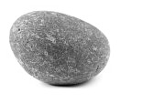
Earth Science 11 Name: ____________________
Date: _______________ Blk: __

PET ROCK PROJECT

OBJECTIVE: to understand the rock cycle by investigating rocks and their mineral components.

PART 1: Pet Rock

- Find a rock. Your rock must be portable (fit in the palm of your hand), obtained legally, and
interesting to you.

- Name your rock. Its name is _________________________________.

- Draw your rock in the box below. Try your best to add as many details as you can.
Label colours, textures, size, etc…

- Break your rock. Using a rock hammer, safely crack your rock to expose a fresh surface.

- Draw the fresh surface of your rock. Label what you see – colours, textures, size, etc…

- Investigate your pet rock by answering the following questions:

- Where and when did you find your rock? Describe the location in detail. Why did you choose this rock to study?
_________________________________________________________________________________________________________________________________________________________________________________________________________________________________
_________________________________________________________________________________________________________________________________________________________________________________________________________________________________

- In what way does the shape and texture of your rock indicate how far it has travelled?
_______________________________________________________________________________________________________________________________________________________________________________________________________________________________________________________________________________________________________________________________________________________________________________________

- What type of rock do you think you have? (Igneous, sedimentary, or metamorphic?)

- Describe why you think it is this type of rock.

Use the following pages in the textbook to get the rock name:

Igneous Rock – p. 119 Sedimentary Rock – p. 142 Metamorphic Rock – p. 146

- What is the rock name of the specific rock you have? _______________________________

- What evidence are you using to decide on the specific rock name?
____________________________________________________________________________________________________________________________________________________________________________________________________________________________________________________________________________________________________________

PART 2: Rock Cycle

Everybody has a story about their life. Your rock does too. Tell that story.

You are to creatively and scientifically tell the story of your pet rock’s trip through the ROCK CYCLE.

- Choose one storytelling method:

Option 1: Film - Option 2: Comic Strip - Option 3: Short Story - Option 4: Song

- Your Story through the Rock Cycle must include:
- Your rock changing from one kind of rock to another.
- You must end with the same rock type as you start with.
- How the rock changes from one type to the other (Which processes?)
- All three main rock types (Igneous, Sedimentary, and Metamorphic)
- Sediment and Magma
- Images illustrating the journey of your rock.

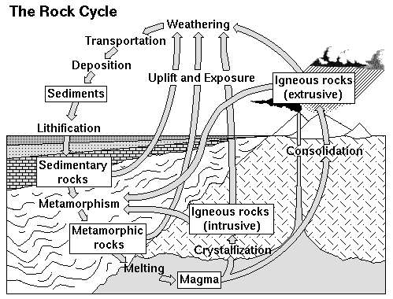

PROJECT DATES
Find your rock: __________________________
Part 1 due: _____________________________
Part 2 due: _____________________________

ROCK CYCLE STORY PLANNING:
- Start with your rock type, and then decide the path through the rock cycle.
- Include the main rock stages and the processes that change the rock from one type to another.

YOUR PET ROCK - Rock Type: _________________________

PET ROCK PROJECT RUBRIC
Learning outcome: students will investigate the Rock Cycle by explaining the processes their Pet Rock undergoes to change from one rock type to another.

CRITERIA | Awesome! :D | Nice job! :) | Ok. :\ | Bueller?
 | 10-9 | 8-7 | 6-5 | 4-0
Rock Type  Information | Includes a detailed description of the three rock types (Extrusive and Intrusive Igneous, Sedimentary, Metamorphic). Includes logical specific rock names examples. Also includes types of sediment and magma. | Includes a description of the three rock types (Igneous, Sedimentary, Metamorphic). Includes specific rock names examples. Also includes types of sediment and magma. | Includes the three rock types (Igneous, Sedimentary, Metamorphic). Also includes sediment and magma. | Did not include information about the rocks, sediment, or magma.
Processes  (HOW the rock changes) | Includes a detailed description of the processes between rock types, sediment, and magma. A logical, detailed, and creative path is chosen through the rock cycle. | Includes a description of the processes between rock types, sediment, and magma. A logical path is chosen through the rock cycle. | Includes the processes between rock types, sediment, and magma.  A path is chosen through the rock cycle. | Did not include information about the processes.
Creative Process & Images | Project shows effort and creativity. Many appropriate images are used to explain ideas. | Project shows effort. Appropriate images are used to explain ideas. | Project shows some effort. Some images are used to explain ideas. | Did not include effort or images.

