Geology 12 Name: __________________________
PLATE TECTONICS UNIT – Summative Assessment Outline
- Your assignment: Choose one or more of the following tasks to complete to show your understanding of our Plate Tectonics Unit.
Reminder – you must complete a minimum of three (3) tasks in each category (A, B, C, D) over the entire year.
- Tasks:
Create a graphic organizer (mind map/concept map/etc) on Plate Tectonics, designed to teach my Earth Science 11 students.  Category A | Take a standard written test on Plate Tectonics.  Study your notebook…  Category A | Design and build your own written test and answer key, to use with my Earth Science 11 class.  Category A
Create your own hypothetical alien world, and design a map showing its Plate Tectonics.  Category C | Investigate how Plate Tectonics has shaped and influenced a specific location on the Earth.  Category D | Build a working model to explain how Plate Tectonics works.  (physical or digital)  Category D
Investigate the impact of Plate Tectonic on the distribution of animal and plant on the Earth.  Category D | Explore Plate Tectonics on other planets.  Category D | Explore the concept of Icy Plate Tectonics, and compare it to Earth’s rocky Plate Tectonics.  Category D
Design your own task that investigates Plate Tectonics!
Check with Bond for approval…
Category A, B, C, or D.

- Format:
- You can show your understanding of Plate Tectonics with these tasks in any format you choice:
(Report, presentation, creative writing, film, model, poetry, art, song, drama, music, skit, etc…)

- If working with a partner/group, you must ADDITIONALLY submit your own evidence of understanding of Plate Tectonics. This will have more weight when I assess your understanding.
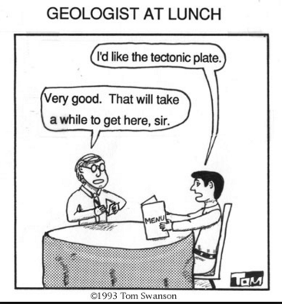
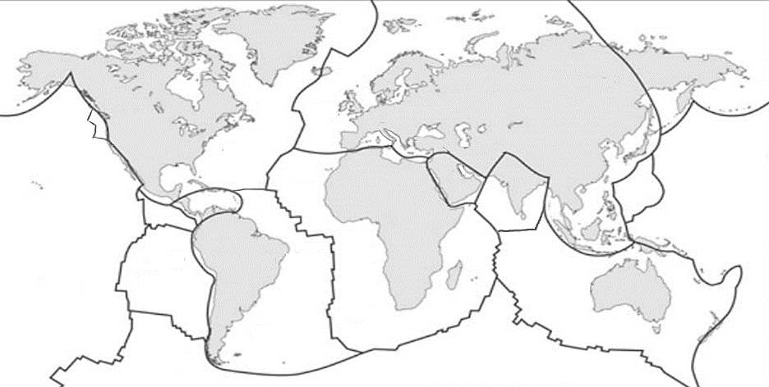

Category A – Knowledge and Understanding
Category B – Inquiring and Planning
Category C – Evaluating, Applying, and Innovating
Category D – Communication and Research

- Your Assignment Plan:
What is your Project Idea(s)?
What Category(s) will be assessed?
When will it be due?
What problems do you predict?

Summative Assessment Rubric
Score | What it means
7 | In addition to Score 5 performance, in-depth inferences and applications that go beyond what was taught. Very few errors.
6 | In addition to Score 5 performance, partial success at inferences and applications that go beyond what was taught.
5 | No major errors or omissions regarding any of the information and/or processes (simple or complex) that were explicitly taught.
4 | No major errors or omissions regarding the simpler details and processes and partial knowledge of the more complex ideas and processes.
3 | No major errors or omissions regarding the simpler details and processes but major errors or omissions regarding the more complex ideas and processes
2 | Partial knowledge of the simpler details and processes but major errors or omissions regarding the more complex ideas and processes
1.0 | With help, a partial understanding of some of the simpler details and processes and some of the more complex ideas and processes
0.5 | With help, a partial understanding of some of the simpler details and processes but not the more complex ideas and processes
0.0 | Even with help, no understanding or skill demonstrated

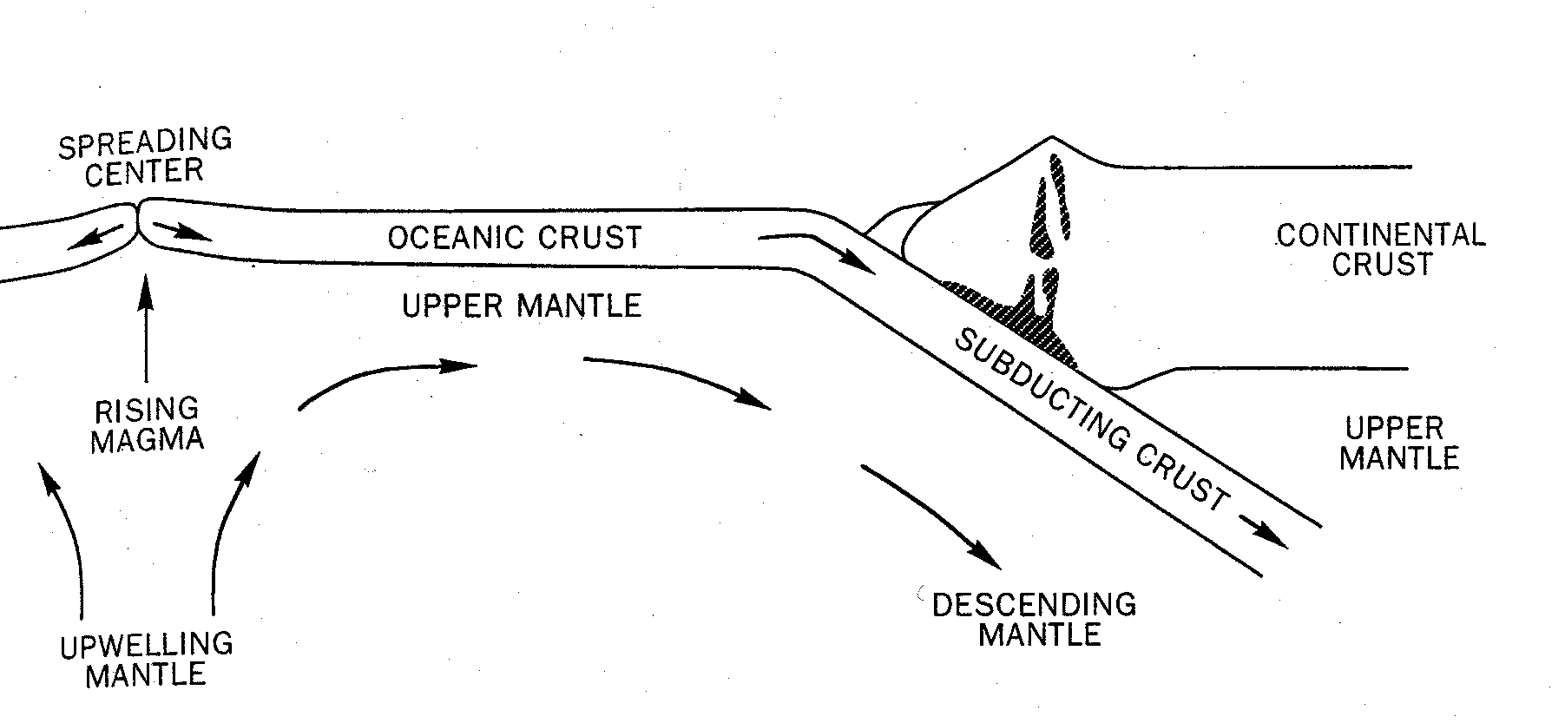
YOUR SCORE:
- Category _____ = ______
- Category _____ = ______

