Earth Science 11 Name: _____________________
Extended Weather Lab Block:________________
Rain Gauge: A rain gauge measures how much rain has fallen in a period (in our case it will be 24 hrs because you will be reading your gauge daily). **Remember, everyday you read the gauge then level the water back to “0”!
Materials:
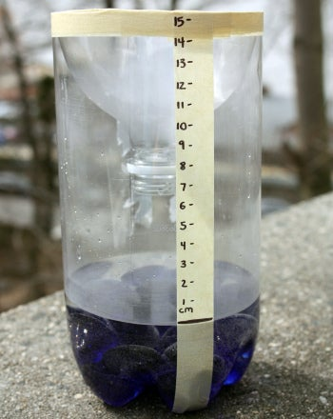
- Empty plastic bottle/jug
- Masking tape
- Handful of small rocks/pebbles
- Water
- Ruler
- Permanent marker

Procedure:
- Gather the necessary materials
- Carefully use the scissors to cut the top of the bottle off at the wide part, just below where it begins to get narrow.
- Put the pebbles in the bottom of the bottle – these will help keep it from getting blown over if it’s windy *this step can be done at home so you don’t need to carry rocks home!
- Turn the top of the bottle (that you cut off) upside down and place it in the bottom part of the bottle, pointing downward. This will act as a funnel. Tape this in place with masking tape
- Use a long piece of tape to make a straight vertical line from the top edge of the bottle to the bottom. Use the marker to draw a line just above the top of the pebbles (This will be the bottom of your gauge)
- Set the ruler against the vertical tape so that the “0” lines up with the bottom mark. Use the marker to mark centimeters on the tape.
- Set the bottle on a level surface and pour some water in until it reaches the bottom mark. Your rain gauge should look like the picture above. You are ready to go!

Research:
In your “expert groups”, you will collaborate to research to fill in the chart below. You will be recording both the rainfall and clouds daily.

Cloud | Drawing/Description | Associated weather
Cumulus
Cumulonimbus
Stratus
Stratocumulus
Altostratus
Altocumulus
Cirrocumulus
Cirrus

