Geology 12 Name:___________________
Date:____________ Blk: ___
Resource Project – Letter to the Mayor
Your resource type: ___________________________________________________________
Your project location: _________________________________________________________
Your Role: You are a citizen in a small town of rural BC. There is a proposed extraction project for the edge of your town. It might as well be in your backyard! The local government is looking for input from local citizens on whether this project should be approved or not.
Your town: Your town is a small town in South-central BC whose industry used to be forestry but the recent forest fires have impacted the economy in town. There is a map of your town below with the star indicating the proposed extraction site.
Your task: Research the environmental and economic impacts on those in your community and its surroundings. Write a letter to the mayor giving and educated, scientific explanation of your stance on the project. Do you think it should be approved or not? What will the benefits be? What about the risks? Are there any caveats to your approval/denial of the project?
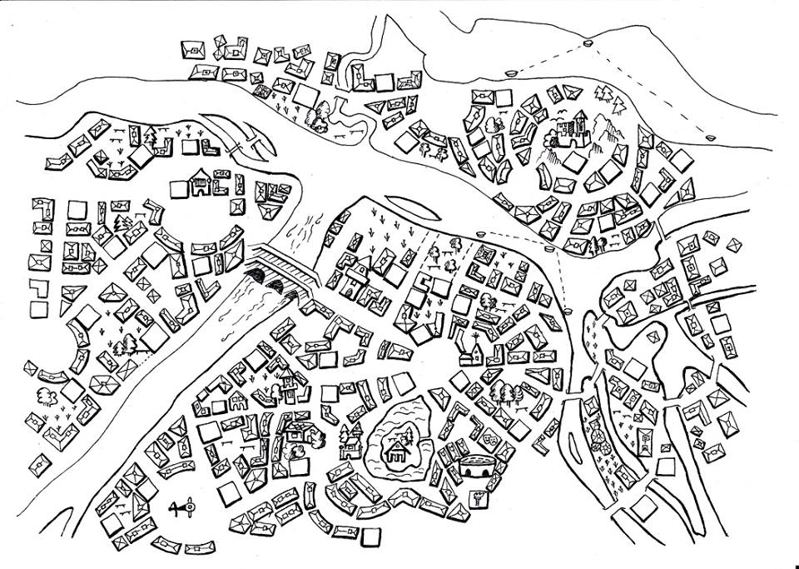
You must include: (Hint: Check these off as you acquire your research) Though the main points are required to discuss, you do not need to answer each question exactly. Dig deep see what you discover and discuss that!
  - Information about the resource itself
    - Extraction (how do we get it out of the ground?)
    - What is it used for now?
    - What is its role in a future of green energy/tech?
  - Impacts of your resource industry on the land (environmental)
    - How will it help or hinder the environment?
    - Will it produce waste rock? Tailings? Etc
    - How much energy or water is used in the extraction process?
    - How might the company approach remediation?
  - Impacts of your resource industry on the people (Social and Economic)
    - You must include multiple perspectives, what does the company say? What do the Indigenous people say/think? Are there other stakeholders?
    - How will it help or hinder the economy?
  - Impacts of your resource industry on global climate change
    - How will it contribute to a greener future economy?
Spice it up! For an additional challenge you may research an actual resource extraction project, or present your findings in some other way (come see me for approval or to discuss)
 | 0 | 1-2 | 3-4 | 5-6 | 7
Assess risks and address ethical, cultural, and/or environmental issues | Student did not meet any of the descriptors | State impacts of resource industry on one of the following: land, people, economy, or climate change. | Outline impacts of resource industry on some of the following: land, people, economy, or climate change. | Discuss impacts of your resource industry on land, people, economy, and climate change. | Analyze impacts of your resource industry on land, people, economy, and climate change.
Apply First Peoples perspectives and knowledge, other ways of knowing, and local knowledge | Student did not meet any of the descriptors | Includes one perspective on the resource extraction project. | Includes multiple perspectives on the resource extraction project. | Includes a detailed analysis of the perspectives of the resource extraction project. | Includes a thorough and detailed analysis of perspectives of the resource extraction project.
Communicate a suggested course of action, for a specific purpose and audience, constructing evidence-based arguments. | Student did not meet any of the descriptors | State a stance on project with limited reference to evidence | Outline a stance on project with reference to evidence | Describe a stance on project with reference to evidence | Explain a stance on project with reference to evidence

Resource Project – Letter to the Mayor
SIGN UP - BLOCK 1
Fracking | _____________________ ______________________  _____________________ ______________________  _____________________ ______________________
Groundwater | _____________________ ______________________  _____________________ ______________________  _____________________ ______________________
Gold (Au) | _____________________ ______________________  _____________________ ______________________  _____________________ ______________________
Copper (Cu) | _____________________ ______________________  _____________________ ______________________  _____________________ ______________________
Coal | _____________________ ______________________  _____________________ ______________________  _____________________ ______________________

Resource Project – Letter to the Mayor
SIGN UP - BLOCK 3
Fracking | _____________________ ______________________  _____________________ ______________________  _____________________ ______________________
Groundwater | _____________________ ______________________  _____________________ ______________________  _____________________ ______________________
Gold (Au) | _____________________ ______________________  _____________________ ______________________  _____________________ ______________________
Copper (Cu) | _____________________ ______________________  _____________________ ______________________  _____________________ ______________________
Coal | _____________________ ______________________  _____________________ ______________________  _____________________ ______________________

