Science 8 Name: __________________
Date: ____________ Blk: __

OVERVIEW of the DIGESTIVE SYSTEM
Scientific Diagram

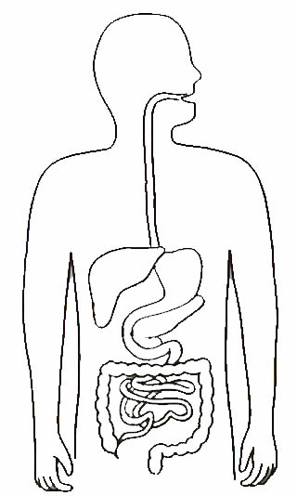
TASK: To draw and label in detail the digestive system of a human.
Use the diagrams in your notes and p. 70 in your text for reference.

You must:
- Draw the Digestive System organs in a body (Excretory System optional)
- Label the organs neatly (use a ruler!)
- Include detailed descriptions of each organ, including their role in mechanical and chemical digestion, and absorption.

Due Thursday December 4th – can be used on the Digestion Quiz that day.

You will be assessed with Criteria A

Criterion A: Knowing and understanding
Achievement  level | Level descriptor
0 | The student does not reach a standard described by any of the descriptors below.
1-2 | The student is able to:  - recall scientific knowledge  - apply information to make judgments.
3-4 | The student is able to:  - state scientific knowledge  - apply information to make scientifically supported judgments.
5-6 | The student is able to:  - outline scientific knowledge  - interpret information to make scientifically supported judgments.
7-8 | The student is able to:  - describe scientific knowledge  - analyse information to make scientifically supported judgments.

