Geology 12 Name: __________________________
SEDIMENTARY UNIT – Summative Assessment Outline
- Your assignment: Choose one of the following tasks to complete to show your understanding of our Sedimentary Rock Unit. Choose which category(s) to assess.
Reminder – you must complete a minimum of three (3) tasks in each category (A, B, C, D) over the entire year.
- Potential Tasks:
Create a graphic organizer  (mind map/concept map/flash cards, etc…)  Category A | Take a standard written test.  Study your notebook, the textbook, and the class ppts…  Category A | Design and build your own written test and answer key  Category A
Do a field study of a local sedimentary environment  (beach, river, stream, lake…)  Category C | Create sedimentary food, clothing, or music  Get creative!  Category D | Build working models to explain how sedimentary structures in specific environments form  Category B
Write a story about the sedimentation process  (memoirs, kidsbook, short stories, diary, newspaper, blog, etc…)  Category A or D | Explore sedimentary rocks on other planets.  Planetary geology!  Category D | Create a film documentary about how sedimentary rocks form  Category D
Design your own task that investigates Sedimentary Rocks!
Check with Bond for approval…
Category A, B, C, or D.

- Format:
- You can show your understanding of Sedimentary Rocks with these tasks in any format you choice:
(Report, presentation, creative writing, film, model, poetry, art, song, drama, music, skit, etc…)

- If working with a partner/group, you must ADDITIONALLY submit your own evidence of understanding of the Unit. This will have more weight when I assess your understanding.
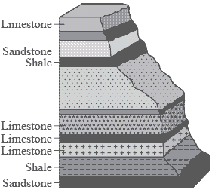
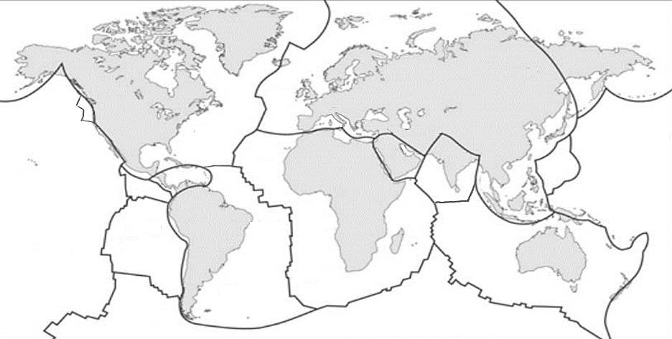
See your Course Outline for explanations of each category:
Category A – Knowledge and Understanding
Category B – Inquiring and Planning
Category C – Evaluating, Applying, and Innovating
Category D – Communication and Research

- Your Assignment Plan:
What is your Project Idea(s)?
What Category(s) will be assessed?
When will it be due? | (Must be on or before Feb. 28)
Think about your project. What problems do you predict you will have?

Summative Assessment Rubric
Score | What it means
7 | In addition to Score 5 performance, in-depth inferences and applications that go beyond what was taught. Very few errors.
6 | In addition to Score 5 performance, partial success at inferences and applications that go beyond what was taught.
5 | No major errors or omissions regarding any of the information and/or processes (simple or complex) that were explicitly taught.
4 | No major errors or omissions regarding the simpler details and processes and partial knowledge of the more complex ideas and processes.
3 | No major errors or omissions regarding the simpler details and processes but major errors or omissions regarding the more complex ideas and processes
2 | Partial knowledge of the simpler details and processes but major errors or omissions regarding the more complex ideas and processes
1.0 | With help, a partial understanding of some of the simpler details and processes and some of the more complex ideas and processes
0.5 | With help, a partial understanding of some of the simpler details and processes but not the more complex ideas and processes
0.0 | Even with help, no understanding or skill demonstrated

YOUR SCORE:
- Category _____ = ______
- Category _____ = ______

