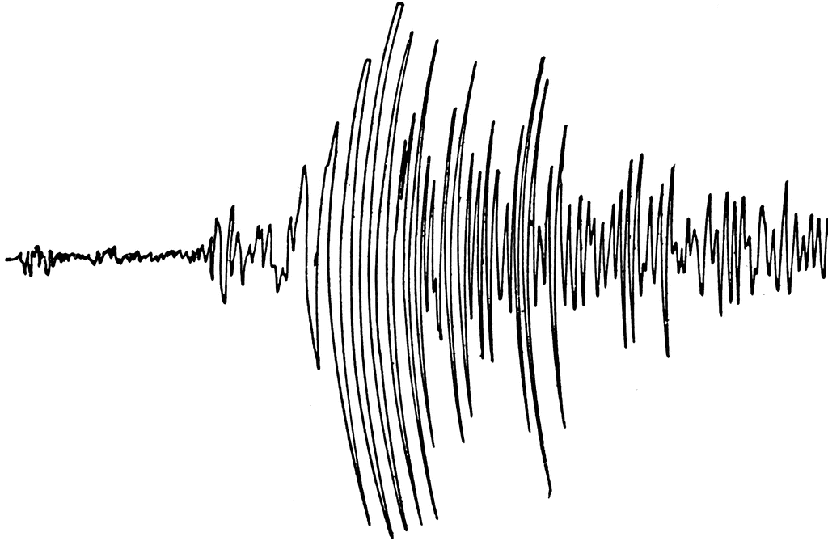
Geology 12 Name: ______________________ Blk: ____

Seismology Unit
Local Earthquake Investigation Project

BIG IDEA: Tectonic plates are in constant motion and their interactions produce earthquakes, volcanoes, and characteristic landforms on the Earth’s surface.

Task: Choose a local site in BC and create a project assessing the seismic risk of the site to share with others.

A. Create a Seismic Impact Assessment report on a local site.
or
B. Create a Story of an earthquake impacting a local site.

1. Choose Project Type:
Paper Report – Documentary Video – News Article – Diorama – Dramatization Play - Song

2. Choose a Local Site:
SUGGESTIONS: Your home, Carson Graham School, North Vancouver, Lonsdale Quay, Cleveland Dam, Lions Gate Hospital, Lions Gate Bridge, Stanley Park, Gastown, Chinatown, Downtown, the Cube building, the Vancouver Hotel, BC Place Stadium, Transit, Delta/Richmond, Vancouver Island, Tofino, Port Alberni, Haida Guaii…

Task (A or B?) | Your Project Type | Your Local Site

3. Research:
-Record all your sources and include them in a reference list. For full marks, use APA format and in-text citations.

Follow your inquiry! RESEARCH SHOULD INCLUDE:
The Geology:
What geology underlies your local site?
How close will the epicenter of the quake be to your site?
How will the local geology affect your site during an earthquake?

Hazards:
What happens during and after the earthquake at your local site?
What hazards are most likely to concern your site?

Preparation:
How prepared is the local site for the quake?
What actions can people take at this location to prevent harm?
What can we do to prepare for the quake?

Websites to begin your investigation:
- Ocean985.com
- ShakeOutBC.ca
- http://theprovince.com/feature/b-c-earthquake-threatens-vancouver-buildings
- http://www2.gov.bc.ca/assets/gov/farming-natural-resources-and-industry/construction-industry/building-codes-and-standards/guides/fs_bcbc_seismic.pdf
- http://www2.gov.bc.ca/gov/content/safety/emergency-preparedness-response-recovery
- https://www.iclr.org/homeowners/earthquakerisktool.html

4. Sharing your Findings:
-Share your seismic assessment report or story with others – make them aware!
-Add your project to the Local Earthquake Investigation blog.

DUE DATE: ___________________________________________________________

RUBRIC:
Assessment Criteria |  | 4  (exceeds expectations) | 3  (meets expectations) | 2  (minimally-meets expectations) | 1  (below expectations)
KNOWLEDGE &  UNDERSTANDING | The Science | Science shows deep understanding and is always accurate.  (Geology, Hazards,  & Preparation) | Science shows understanding and is accurate.  (Geology, Hazards, & Preparation) | Science shows minimal understanding.  (Geology, Hazards, & Preparation) | Science does not show understanding.  (Geology, Hazards, & Preparation)
 | The Research | Research is extensive and properly documented in APA format with in-text citations. | Research is extensive and documented in APA format. | Research is limited and documented with websites only. | Research is limited and not documented.
SKILLS | The Project and Communication | Project effectively and creatively displays knowledge completely.  Wow! | Project effectively displays knowledge.  Well done! | Project displays some elements of your knowledge.  Keep trying. | Project is not completed or does not display any knowledge.

