First Nations chief suggests Slhx̱í7lsh as the new name for Stanley Park's Siwash Rock

Chief's suggestion comes after park board votes to work with First Nations on new name
Cory Correia · CBC News · October 13, 2017
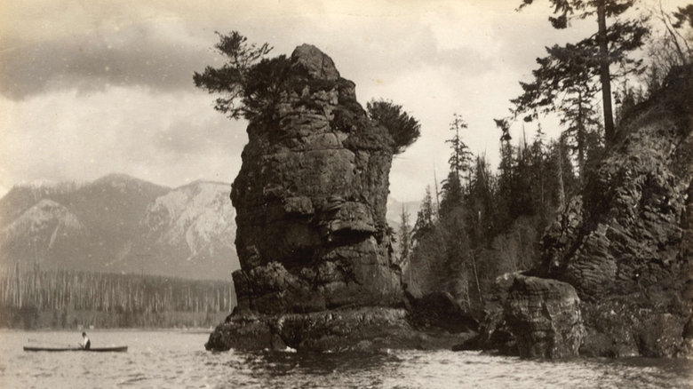
Taken in 1889 or 1890, this photo shows a man in a canoe paddling past Siwash Rock. The City of Vancouver says the picture is part of an album originally owned by 'pioneers,' donated to the archives in 2008. (City of Vancouver Archives)
One of three Coast Salish First Nations approved to rename Stanley Park's iconic Siwash Rock is proposing the name, Slhx̱í7lsh, or "standing man," in the Squamish language.
According to Squamish First Nations legend, a man was preparing for the arrival of his child when he was immortalized by being transformed into the stone we see today as a reward for unselfish fatherhood.
On Wednesday, the park board voted unanimously to work with the Squamish, Musqueam and Tsleil-Waututh First Nations to rename the basalt rock between Third Beach and the Lions Gate Bridge.
"I think this is an opportunity for authenticity where the real names that Coast Salish peoples, particularly Musqueam, Squamish, Tsleil-Waututh have used for thousands of years should be recognized when everything else is in English," said Squamish First Nations Chief Ian Campbell.
"There's really no presence in the park to add value of the contributions and the homelands of our people."
He says the three First Nations have slight variations in how they spell and pronounce the name, so they will have to discuss how to proceed.
Siwash Rock's current name is a Chinook word originating from the French, "sauvage", meaning savage.
Vancouver Park Board commissioner Catherine Evans called the name "an ongoing symbol of disrespect" to Indigenous Peoples.

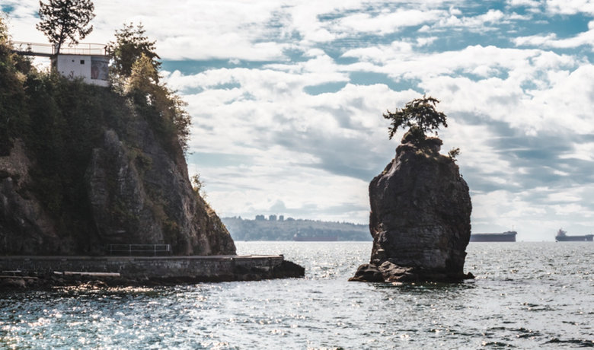
Siwash Rock, between Third Beach and the Lions Gate Bridge, is a 32-million-year-old sea stack. (Shutterstock)

Discussion Questions:
1. Use google to find out what geologic feature Slhx̱í7lsh/Siwash Rock is.

2. Should Siwash Rock be renamed?

3. List other natural Vancouver landmarks and their traditional First Nation’s names. (eg. Stanley Park, Squamish)

4. In your opinion, should all natural Vancouver landmarks be renamed with their traditional First Nation’s names?

