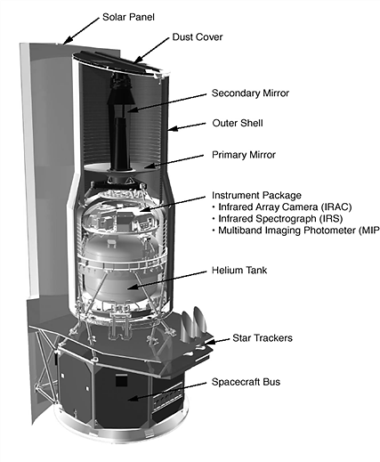
Science 8 Name: _______________________ Blk: ___

Reflection on Space Telescope Project
Attach this reflection to the end of your Space Telescope Proposal.

- How do lenses and mirrors allow us to see far out into space?

- Is the James Webb Space Telescope worth the 8.8 billion dollar cost?
Explain why/why not.

- How has this experience (creating a space telescope) helped you understand light better?

- How can we change this project next year to make it better?

