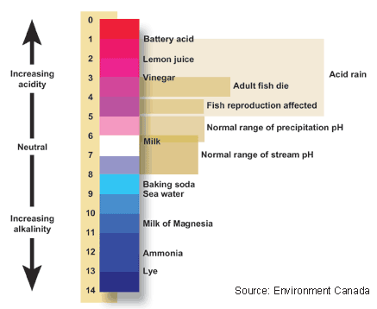
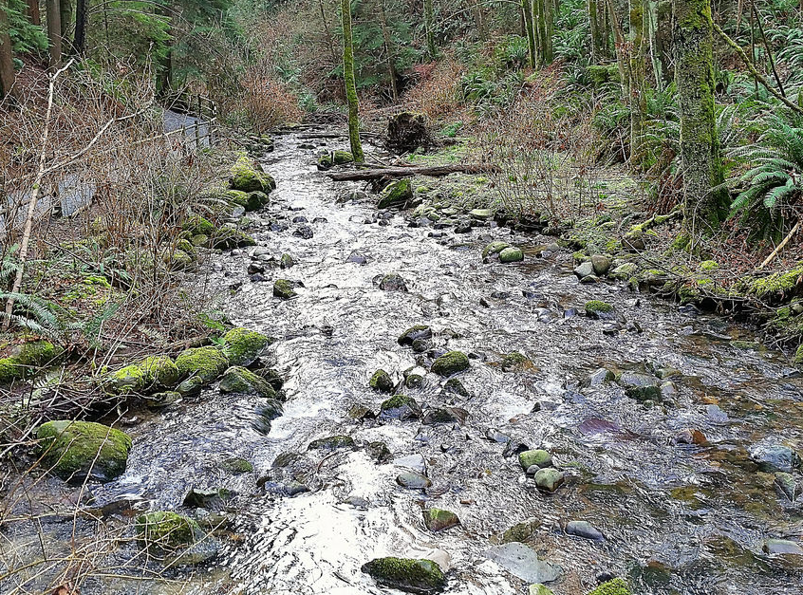
Names: ______________________
Date: _________________ Blk: __

Design Lab
Scenario – Chemistry of a Stream

You will design a lab to investigate the chemistry of a local stream – Wagg Creek.

Brainstorm: What are some things you can investigate about the stream?

Consider: You need to be able to clearly and simply explain the one change you will alter in your experiment design. Do you already know the answer to any of your ideas?

Criterion B and C – Experimental Design and Analysis
(Filling out this package will only get you to a 3-4 level. Rewrite your work on other paper with more space for higher levels!)

- Explain the problem or question your experiment is trying to answer. Try to relate it to the real world.

- What is your experimental design organization?
-Before writing your hypothesis, you must explain how you will manipulate your variables, and explain how
sufficient, relevant data will be collected.

INDEPENDENT VARIABLE  What ONE thing you are changing (manipulating) in different groups. | My independent variable is: | - How many trials? (the number of times I will repeat the experiment)  - How many groups? (the number of changes to your independent variable)  What are the groups?
DEPENDENT VARIABLE  What you are measuring. | My dependent variable is: | - How I will measure this:  (What will you record as data? What units?)
CONTROL VARIABLES  What conditions you are keeping the same between all groups, to ensure a fair test. | My control variables are: (list as many as you can, and how you will control them!)

- Hypothesis
  - This is often referred to as an “educated guess” or prediction, but it must be testable (which it will be if you include your one independent and dependent variables!)
  - Follows the “If… then… because…” format.
  - If you need to do research to answer the “because” section, don’t forget to use proper in-text citation and add the source to your reference list in an APA reference page.

- Materials list
-Make a detailed list of all materials you need for your experiment. Include amounts. BULLET POINTS please!

- Experiment set-up
-Make a diagram (drawing) of the apparatus you will be using to carry out your experiment. Label all parts.

- Procedure
-This is a step-by-step NUMBERED list detailing exactly what someone needs to do to perform the exact same experiment as you. Remember that strong experiment design includes multiple trials in each group.
(eg. There are 5 plants (trials) in each different soil type (groups))
- Include safety and ethical considerations in your procedure.

- Data collection
-Quantitative: Design a data table in which to collect your experimental data (include your independent
variable on the side and your dependent variable on top.)

-Qualitative: take notes on what you are doing and what is observed. These notes can help you recall the
experiment when you answer discussion question afterward.

- Create a graph showing the results of your experiment. Use graph paper.
- Use pencil to correct any errors.
- Independent variable is on the X-AXIS
- Dependent variable is on the Y-AXIS
- Your graph needs a title.

- Results
Summarize and interpret your data (use numbers from your data!) and then explain your results.

- Restate your hypothesis and evaluate if your hypothesis is supported or not supported by your results.
Use specific data from your experiment as evidence to explain why.

- Discussion question: Evaluate the validity of your procedure based on the outcome of the experiment. Discuss any errors or problems in your design procedure and make suggestions for how they can be fixed.

- Discussion question: Explain improvements you would make to your procedure.

- Discussion question: Explain extensions you make to your experiment. What other experiment can you suggest to investigate your problem?

- Communicate results
-Share the results of your experiment with other people in your class. How did your findings compare to those of other students?

Assessment Rubrics
Level | Level descriptor Criterion B: Inquiring and designing
0 | The student does not reach a standard described by any of the descriptors below.
1-2 | - state a problem or question to be tested by a scientific investigation  - outline a testable hypothesis  - outline the variables  - design a method, with limited success
3-4 | - outline a problem or question to be tested by a scientific investigation  - formulate a testable hypothesis using scientific reasoning  - outline how to manipulate the variables, and outline how relevant data will be collected  - design a safe method in which he or she selects materials and equipment
5-6 | - describe a problem or question to be tested by a scientific investigation  - formulate and explain a testable hypothesis using scientific reasoning  - describe how to manipulate the variables, and describe how sufficient, relevant data will be collected  - design a complete and safe method in which he or she selects appropriate materials and equipment
7-8 | - explain a problem or question to be tested by a scientific investigation  - formulate and explain a testable hypothesis using correct scientific reasoning  - explain how to manipulate the variables, and explain how sufficient, relevant data will be collected  - design a logical, complete and safe method in which he or she selects appropriate materials and equipment

Level | Level descriptor Criterion C: Processing and evaluating
0 | The student does not reach a standard described by any of the descriptors below.
1-2 | - collect and present data in numerical and/or visual forms  - interpret data  - state the validity of a hypothesis based on the outcome of a scientific investigation  - state the validity of the method based on the outcome of a scientific investigation  - state improvements or extensions to the method.
3-4 | - correctly collect and present data in numerical and/or visual forms  - accurately interpret data and explain results  - outline the validity of a hypothesis based on the outcome of a scientific investigation  - outline the validity of the method based on the outcome of a scientific investigation  - outline improvements or extensions to the method that would benefit the scientific investigation.
5-6 | - correctly collect, organize and present data in numerical and/or visual forms  - accurately interpret data and explain results using scientific reasoning  - discuss the validity of a hypothesis based on the outcome of a scientific investigation  - discuss the validity of the method based on the outcome of a scientific investigation  - describe improvements or extensions to the method that would benefit the scientific investigation.
7-8 | - correctly collect, organize, transform and present data in numerical and/ or visual forms  - accurately interpret data and explain results using correct scientific reasoning  - evaluate the validity of a hypothesis based on the outcome of a scientific investigation  - evaluate the validity of the method based on the outcome of a scientific investigation  - explain improvements or extensions to the method that would benefit the scientific investigation.

