Earth Science 11 Name: _____________________
Extended Weather Lab Block:________________
Thermometer: A thermometer tracks the temperature of the air. In this lab, you will have to build and calibrate your own thermometer.
Materials:
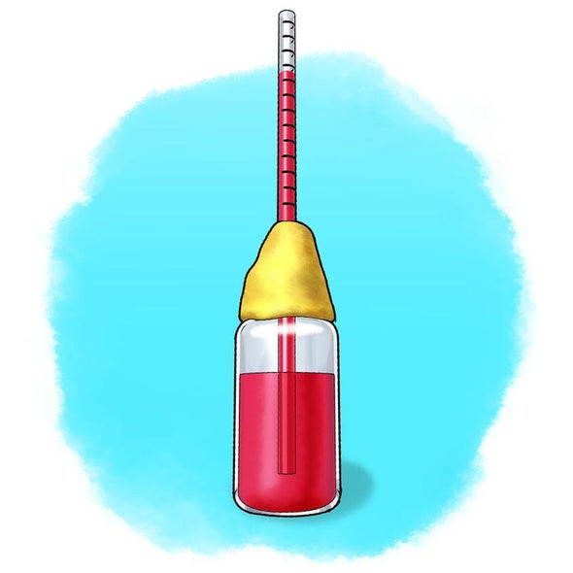
- Clear plastic drinking straw
- Ruler
- Fine-tipped permanent marker
- Small plastic bottle with lid
- Water
- Rubbing alcohol
- Food colouring
- Modeling Clay
- Pipette
- Hot water
- Ice cubes

Procedure:
- Gather the necessary materials
- Use a permanent marker to make small marks on the straw, from the top down, at half-centimeter intervals
- Add rubbing alcohol to the bottle, filling it about halfway up. (Reseal the bottle immediately)
- Add a couple drops of food colouring to colour the alcohol
- Fill a pipette with the coloured alcohol and carefully set it aside making sure none can leak out.
- Make a small hole in your clay and poke the straw through. Place the clay on the bottle’s neck so the straw hangs in the bottle. Adjust the straw so the end is immersed in the liquid but does not touch the bottom of the bottle.
- Use the clay to make a tight seal around the top of the bottle and around the straw.
- Drip the content of your pipette – drop by drop – into the straw, building up the level of liquid in the straw.
- To test place the bottom of the thermometer in a bowl of hot or cold water, what happens to the liquid in the straw?

Calibrate:
As a group, with the thermometer provided. Determine a way to “calibrate” your homemade thermometers. Mark your scale on the straw or make a separate key/chart for your calibration. Now you can measure actual air temperature!

