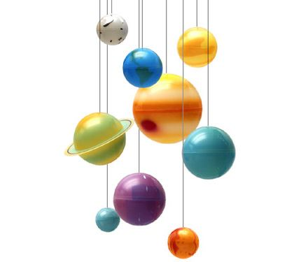Science 10 – Summer Learning Name: _______________________

**THE UNIVERSE FINAL FREE INQUIRY PROJECT**

**Big Idea**: The formation of the universe can be explained by the Big Bang theory.

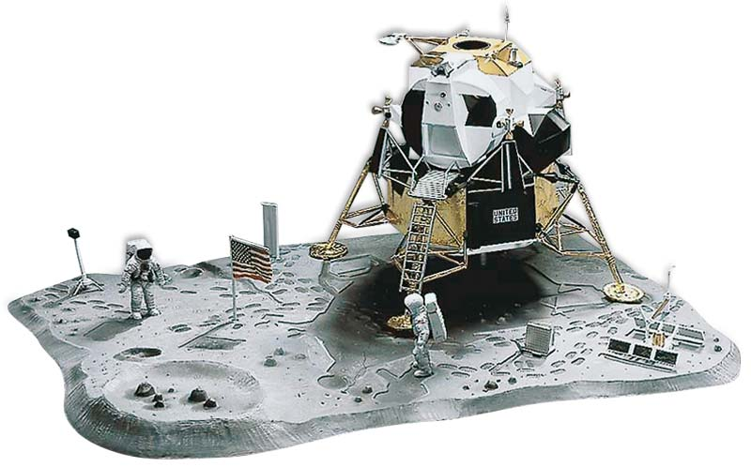

**Task**: to deeply investigate a topic in Astronomy that you are personally interested in.

* This is an **individual** investigation.

**Steps:**

**1. Choose a Subject.** Choose a subject in Astronomy that **interests** you:

***Exploring the Solar System***

* *The Sun*

Formation, Structure, Flares, Sunspots

* *The Moon*

Formation, Structure, Surface, Tides

* *Lagrange Points*
* *Other Planet-Moons System*

eg. Mars-Phobos-Deimos

* *The Solar System*

**Planets**: Mercury, Venus, Mars, Jupiter, Saturn, Uranus, Neptune

**Dwarf Planets**: Pluto, Ceres, Eris…

**Moons:** Europa, Io, Enceladus, Titan…

* *The Asteroid Belt*
* *Kuiper Belt*
* *Oort Cloud*
* *Comets / Meteors / Asteroids*
* *Should we invest in planetary protection from impacts?*
* *Where should we colonize?*
* *How do astronauts survive long deep space voyages?*

***Exploring the Universe***

* *Types of Stars (Giants/Dwarfs)*
* *Constellations*
* *Exoplanets (Super-Earths?)*
* *Supernovas vs Hypernovas*
* *Types of Galaxies*
* *Nebulae*
* *Black Holes*
* *Quasars / Pulsars*
* *Worm Holes*
* *Dark Matter / Dark Energy*
* ***The Big Bang Theory***
* *The Expanding Universe*
* *Heat Death of the Universe*
* *Big Crunch vs Big Rip*
* *The Multiverse Hypothesis*
* *Time Dilation*
* *What is Gravity?*
* *Are we alone in the Universe?*
* *Drake Equation*
* *Fermi Paradox*
* *Can we go faster the light speed?*
* *What was before the Big Bang?*
* *What is beyond the Universe?*
* *What is nothing?*

***Human Space Exploration***

* *Telescopes:*

Hubble, James Webb, Spitzer, Kepler, Chandra, Herschel, Arecibo, VLA…

* *Human Spacecraft:*

Rockets, Space Shuttle, International Space Station (ISS), Soyuz, Space Launch System (SLS), Orion, Dragon…

* *Satellites and Probes*

Sputnik, Voyager, Cassini*,* New Horizons, Rosetta, Juno…

* *Moon Landing*

Apollo 11, Luna, Chang’e…

* *Mars Rovers*

Spirit, Opportunity, Curiosity…

* *Space Exploration Disasters:*

Apollo 1, Apollo 13, SS Challenger, SS Columbia…

*Private Spacecraft:*

SpaceX, Virgin Galactic, Blue Origin, Orbital Sciences Corp

* *Future Technologies*

Space Elevator, Asteroid Mining, Solar Sails, Robots, FTL drives,

* *Should we invest in space exploration?*

**2. Ask an Essential Question that will direct your research:**

* A question you do not already know the answer to.
* Is appropriately challenging. Not a simple question. Not a *Yes* or *No* question.
* How…” or “Why…” or “To what extent…” or “What is the relationship between…”

**Essential question:**

**Explain** **why** this essential question is of personal significance to you.

*Teacher approval: ___________*

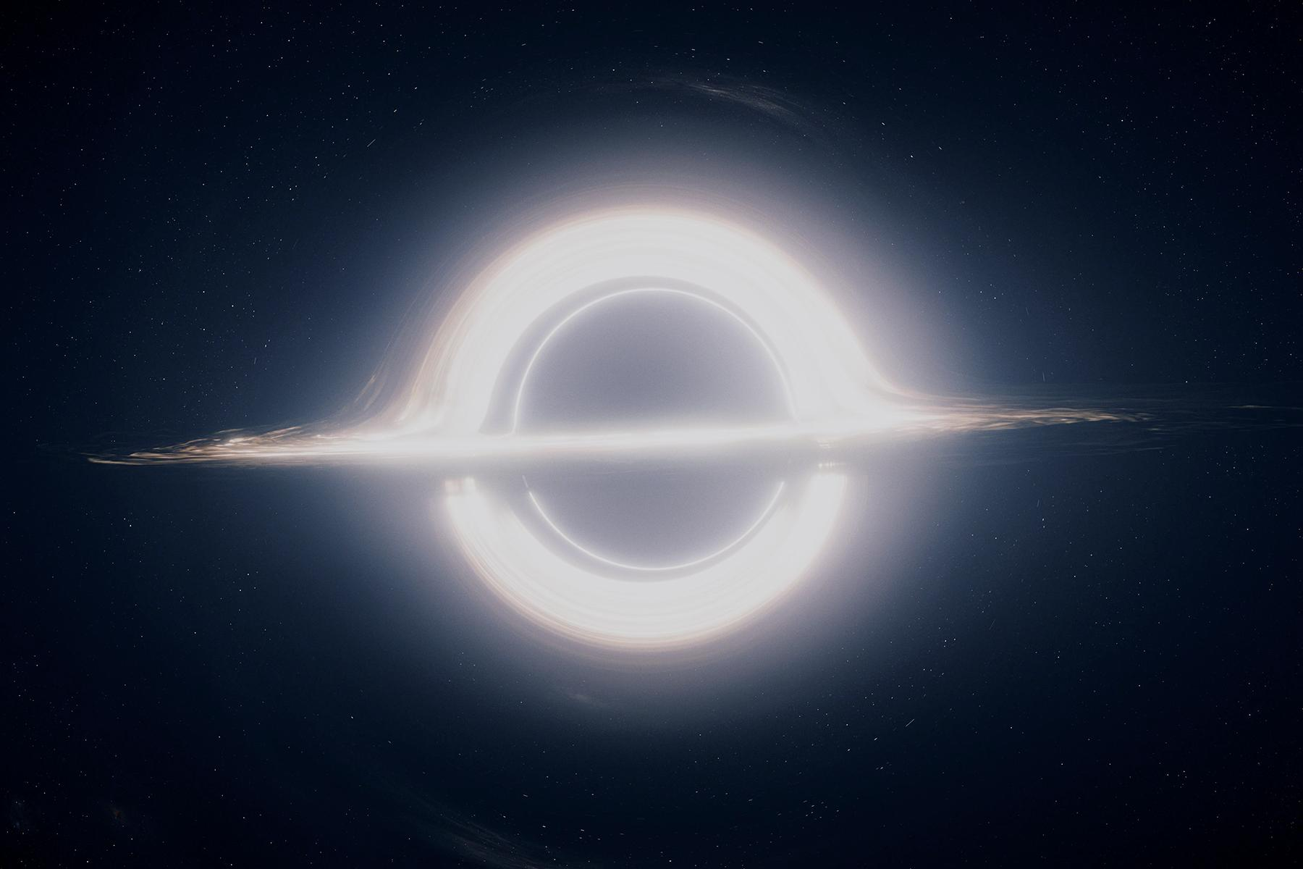**3. Research your Subject and answer your Driving Question:**

* 1. Record your findings using proper APA format in a Reference list and in-text citations.

**4. Design and Build a Visual Product: that answers your essential question**

1. *- Movie – Play – Poster – Model – Presentation – Artwork – Vlog -*
2. **Product Type:**

*Teacher approval: ___________*

**5. Presentation:**

* 1. You will be sharing your product in a **gallery walk/share** on the last day of classes,
  2. **Wednesday August 1st.**

**6. Self-Assessment.**

Below, self-assess your Project and indicate your level. Submit this sheet with your project.

|  |  |  |
| --- | --- | --- |
| **Self** | **Level** | **Level descriptor Criterion A: Knowing and understanding** |
|  | 0 | The student **does not** reach a standard described by any of the descriptors below. |
|  | 1-2 | * **state** scientific knowledge * apply scientific knowledge and understanding to **suggest solutions** to problems set in **familiar situations** * **interpret** information to make **judgments** |
|  | 3-4 | * **outline** scientific knowledge * apply scientific knowledge and understanding to **solve problems** set in **familiar situations** * **interpret** information to make **scientifically supported judgments** |
|  | 5-6 | * **describe** scientific knowledge * apply scientific knowledge and understanding to **solve problems** set in **familiar situations** and **suggest solutions** to problems set in **unfamiliar situations** * **analyse** information to make **scientifically supported judgments** |
|  | 7-8 | * **explain** scientific knowledge * apply scientific knowledge and understanding to **solve problems** set in **familiar and** **unfamiliar situations** * **analyse** and **evaluate** information to make **scientifically supported judgments** |

**Assessment Rubric:**

**Explain WHY you gave yourself this level:** *(use other paper for more space…)*

|  |  |  |
| --- | --- | --- |
| **Self** | **Level** | **Level descriptor Criterion D: Reflecting on the impacts of science** |
|  | 0 | The student **does not** reach a standard described by any of the descriptors below. |
|  | 1-2 | * **outline** the ways in which science is used to address a specific problem or issue * **outline** the implications of using science to solve a specific problem or issue, interacting with a factor * **apply** scientific language to communicate understanding but does so **with limited success** * document sources, with **limited success** |
|  | 3-4 | * **summarize** the ways in which science is used to address a specific problem or issue * **describe** the implications of using science to solve a specific problem or issue, interacting with a factor * **sometimes apply** scientific language to communicate understanding * **sometimes** document sources correctly |
|  | 5-6 | * **describe** the ways in which science is used to address a specific problem or issue * **discuss** the implications of using science to solve a specific problem or issue, interacting with a factor * **usually apply** scientific language to communicate understanding **clearly and precisely** * **usually** document sources correctly |
|  | 7-8 | * **explain** the ways in which science is used to address a specific problem or issue * **discuss and evaluate** the implications of using science to solve a specific problem or issue, interacting with a factor * **consistently apply** scientific language to communicate understanding **clearly and precisely** * document sources **completely** |

**Explain WHY you gave yourself this level:**