Earth Science 11 Name: _____________________
Extended Weather Lab Block:________________
Weather Vane: A weather vane measure the direction that the wind is coming from. Wind brings new weather with it, the direction the wind is coming from determines what weather is coming next. With this instrument you will record the wind direction and research what that means for future weather.
Materials:
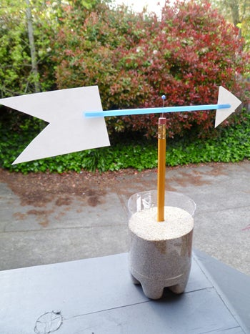
- Construction paper/card stock
- Straw
- Tape
- Pencil
- Pushpin/thumbtack
- 1 liter plastic bottle or large drinking cup
- Sand
- Permanent marker

Procedure:
- Gather the necessary materials
- If using a pop bottle, cut the top half off
- On the outside of your container, mark the compass directions (N, E, S, & W) making sure they are spaced a quarter of the way around each (ask Ms. Abbott for help!)
- Fill your container with enough sand so the pencil will stay upright
- Cut a tail and point for you wind vane out of card stock. The tail must be much larger than the point to catch the wind
- Carefully cut a short slit at either end of the straw, insert your tail and point. Tape them in place
- Using your pushpin, attach your straw to the top of your pencil
- *Your windvane should look as pictured above, test your windvane to make sure it spins.
- **When you set up your windvane at home you must ensure that the North marked on your windvane matches the North or earth.

Research:
In your “expert groups”, you will collaborate to research to answer the questions below. You will be asked to share/teach this to your “mixed groups”. If you need additional space, record your answers in your Earth Science notebooks.
- What does this tool tell you about wind? Are you measuring where the wind is coming from or where the wind is going to?

- What does wind direction tell you about the future weather?

- In Vancouver if the wind is coming from each of the directions listed, what type of weather is coming next?
North
South
East
West

